

**ONLINE SHOPPING PLATFORM FOR STUDENTS, TEACHERS AT FPTU**

**Software Design Document**

– HoChiMinh, September 2022 –

**Table of Contents**

I. Overview **9**

1. Code Packages/Namespaces 9

2. Database Schema 10

**II. Code Designs** **13**

1. <LOGIN > 13

b. Class Specifications 14

UserController Class 14

UserDAO Class 14

DButil Class 14

c. Sequence Diagram(s) 14

d. Database queries 15

2. <SORT> 15

a. Class Diagram 15

b. Class Specifications 16

Homecontroller Class 16

ProductDAO Class 16

ProductImageDAO Class 16

DButil Class 16

c. Sequence Diagram(s) 17

d. Database queries 17

3. <LOAD CATEGORY> 18

a. Class Diagram 18

b. Class Specifications 18

Homecontroller Class 18

CategoryDAO Class 18

DButil Class 18

c. Sequence Diagram(s) 19

d. Database queries 19

4. <SEARCH> 19

a. Class Diagram 20

b. Class Specifications 21

Homecontroller Class 21

GetProductAjax Class 21

ProductDAO Class 21

DButil Class 21

c. Sequence Diagram(s) 21

d. Database queries 22

5. <PRODUCT DETAIL> 23

a. Class Diagram 23

b. Class Specifications 24

HomeController Class 24

ReviewDAO Class 24

ReviewImageDAO Class 24

UserDAO Class 24

ProductDAO Class 24

ProductImageDAO Class 25

DButil Class 25

c. Sequence Diagram(s) 25

d. Database queries 26

6. <BUY PRODUCT> 27

a. Class Diagram 27

b. Class Specifications 28

CartController Class 28

OrderDAO Class 28

OrderByShopDAO Class 28

OrderDetailDAO Class 28

ProductDAO Class 28

DButil Class 30

c. Sequence Diagram(s) 30

d. Database queries 31

7. <BANNER> 31

a. Class Diagram 31

b. Class Specifications 32

HomeController Class 32

BannerDAO Class 32

DButil Class 32

c. Sequence Diagram(s) 33

d. Database queries 33

8. <PRODUCT AUTHENTICATION> 34

a. Class Diagram 34

b. Class Specifications 34

Admin Controller Class 34

ProductDAO Class 35

ProductImageDAO Class 35

c. Sequence Diagram(s) 35

d. Database queries 35

9. <DELETE PRODUCT ON WEBSITE> 37

a. Class Diagram 37

b. Class Specifications 37

Admin Controller Class 37

ProductDAO Class 37

ProductImgaeDAO Class 37

DBUtil Class 38

c. Sequence Diagram(s) 38

d. Database queries 38

10. <DASHBOARD> 39

a. Class Diagram 39

b. Class Specifications 39

DBUtil Class 39

AdminController Class 39

OrderDAO Class 40

UserDAO Class 40

ReviewDAO Class 40

ProductDAO Class 40

c. Sequence Diagram(s) 40

d. Database queries 41

11. <REVIEW AUTHENTICATION> 42

a. Class Diagram 42

b. Class Specifications 42

AdminController Class 42

ReviewDAO Class 42

DBUtil Class 42

ReviewImageDAO Class 43

UserDAO Class 43

c. Sequence Diagram(s) 43

d. Database queries 43

12. <DELETE REVIEW ON WEBSITE> 44

a. Class Diagram 44

b. Class Specifications 44

AdminController Class 44

ReviewDAO Class 45

DBUtil Class 45

ReviewImageDAO Class 45

UserDAO Class 45

c. Sequence Diagram(s) 45

d. Database queries 46

13. <PROMOTE ROLE> 46

a. Class Diagram 46

b. Class Specifications 47

AdminController Class 47

UserDAO Class 47

DBUtil Class 47

c. Sequence Diagram(s) 47

d. Database queries 48

14. <CREATE NEW PRODUCT> 48

a. Class Diagram 48

b. Class Specifications 48

ProductImageDAO Class 48

DBUtil Class 48

c. Sequence Diagram(s) 49

d. Database queries 49

15. <CART> 49

a. Class Diagram 50

b. Class Specifications 50

CartController Class 50

c. Sequence Diagram(s) 51

d. Database queries 51

16. <USER DETAIL> 53

a. Class Diagram 53

b. Class Specifications 53

UserDAO Class 53

DBuitlClass 53

UserControllerClass 54

c. Sequence Diagram(s) 54

d. Database queries 54

17. <SHOP PAGE> 55

a. Class Diagram 55

b. Class Specifications 55

UserDAO 55

OrderByShopDAO 55

ProductDAO Class 56

c. Sequence Diagram(s) 57

d. Database queries 57

18. <BILL DETAIL> 59

a. Class Diagram 59

b. Class Specifications 59

OrderDAO 59

OrderByShopDAO 59

OrderDetailDAO 60

ProductDAO Class 60

c. Sequence Diagram(s) 61

d. Database queries 61

19. <SELLER PAGE> 63

a. Class Diagram 63

b. Class Specifications 63

ProductDAO Class 63

c. Sequence Diagram(s) 64

d. Database queries 64

20. <PURCHASE HISTORY> 66

a. Class Diagram 66

b. Class Specifications 67

OrderDAO 67

OrderByShopDAO 67

OrderDetailDAO 67

ProductDAO Class 67

c. Sequence Diagram(s) 68

d. Database queries 68

21. <PAYMENT> 69

a. Class Diagram 70

b. Class Specifications 70

GhnApi 70

OrderDAO 70

OrderByShopDAO 70

OrderDetailDAO 70

ProductDAO Class 70

c. Sequence Diagram(s) 71

d. Database queries 71

22. <REVIEW> 72

a. Class Diagram 73

b. Class Specifications 73

ReviewDAO 73

ReviewImageDAO 73

c. Sequence Diagram(s) 74

d. Database queries 74

**III. Database Tables** **75**

1. < city > 75

2. < district > 75

3. < Ward > 75

4. < Role > 75

5. < user > 75

6. < category > 76

7. < delivery_method > 76

8. < payment_method > 76

9. < product > 76

10. < image_product > 77

11. < order > 77

12. < order_detail> 77

13. < order_by_shop> 78

14. < review > 78

15. < image_review > 78

16. < banner > 78

# I. Overview

## 1. Code Packages/Namespaces

*[Provide the package diagram for each sub-system. The content of this section including the overall package diagram, the explanation, package and class naming conventions in each package. Please see the sample and description table format below – following Java project naming convention]*

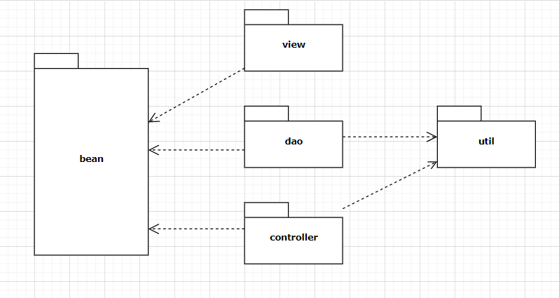

***Package descriptions & package class naming conventions***

| **No** | **Package** | **Description** |
| --- | --- | --- |
| 01 | bean | * Entity class * Classname + “DTO” (ex: ProductDTO.java) |
| 02 | view | * Is used for holds view for user and admin * lowerCase (ex:mainpage.jsp) |
| 03 | controller | * Is used for holds web controllers in MVC 2 models * Classname + “controller” (ex: HomeController.java) |
| 04 | dao | * Is used for holds class * Classname + “DAO” (ex: ProductDAO.java) |
| 05 | util | * The util methods should be moved to a helper or utility class or encapsulated within the class that uses them * Camelcase (ex: myToy.java) |

## 

## 

## 2. Database Schema

*[Provide the tables relationship like example below – following MySQL database naming convention]*

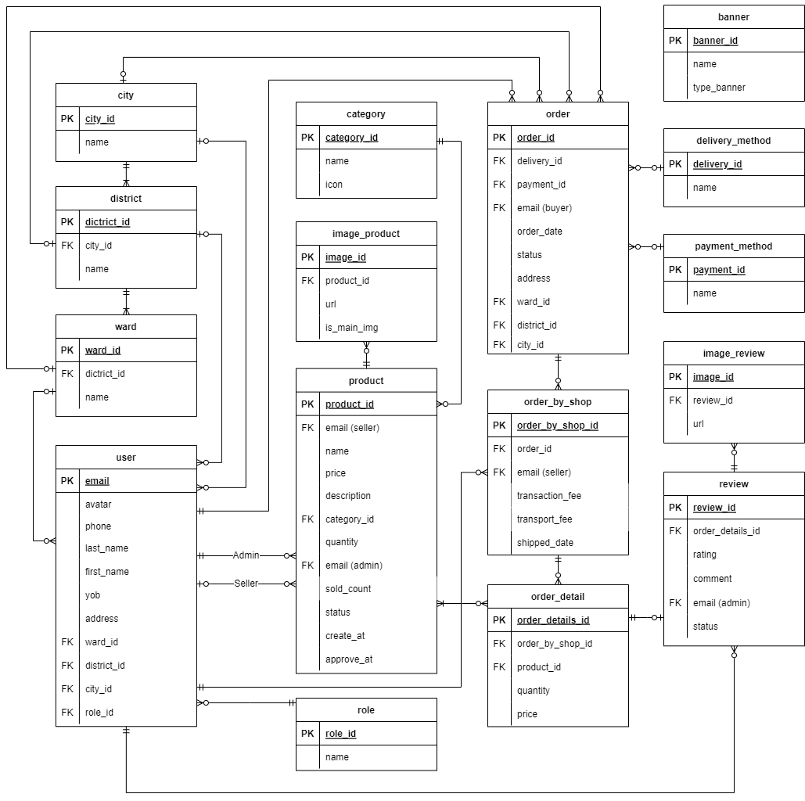

***Table descriptions & package class naming conventions are as below***

| **No** | **Table** | **Description** |
| --- | --- | --- |
| 1 | user | - Primary keys: email  - Foreign keys: ward_id, district_id, city_id, role_id  - Contains information of all accounts logged into the shop |
| 2 | role | - Primary keys: role_id  - Assign roles to accounts such as admin, sub-admin, user |
| 3 | product | - Primary keys: product_id  - Foreign keys: email(seller), category_id, email(admin)  - Contains information about all products posted by the user for sale |
| 4 | order | - Primary keys: order_id  - Foreign keys: delivery_id, payment_id, email(buyer), ward_id, district_id, city_id  - Contains information about the products ordered by the user (paid/unpaid) |
| 5 | order_detail | - Primary keys: order_detail_id  - Foreign keys: order_by_shop_id, product_id  - Contains detailed information about the products the user has ordered (including the purchase price) |
| 6 | order_by_shop | - Primary keys: order_by_shop_id  - Foreign keys: order_id, email (seller)  - Order product list in cart by store and store payment information |
| 7 | category | - Primary keys: category_id  - Contains kinds of products |
| 8 | image_product | - Primary keys: image_id  - Foreign keys: product_id  - Contains the description picture of the product |
| 9 | delivery_method | - Primary keys: delivery_id  - Contains shipping methods such as: direct delivery, shipping by ahamove, ... |
| 10 | payment_method | - Primary keys: payment_id  - Contains payment types such as: direct payment, paypal payment,... |
| 11 | review | - Primary keys: review_id  - Foreign keys: email (admin), order_detail_id  - Contains buyer feedback on their orders |
| 12 | image_review | - Primary keys: image_id  - Foreign keys: review_id  - Image archive of the review |
| 13 | ward | - Primary keys: ward_id  - Foreign keys: district_id  - Contains information about the ward (location) |
| 14 | district | - Primary keys: district_id  - Foreign keys: city_id  - Contains information about the district (location) |
| 15 | city | - Primary keys: city_id  - Contains information about the city (location) |
| 16 | banner | - Primary keys: banner_id  - Contains slider: url, type (show in website) |

# 

# 

# 

# 

# 

# II. Code Designs

## 1. <LOGIN >

*[Provide the detailed design for the function <Feature/Function Name1>. It include Class Diagram, Class Specifications, and Sequence Diagram(s)]*

**a. Class Diagram**

*[This part presents the class diagram for the relevant feature]*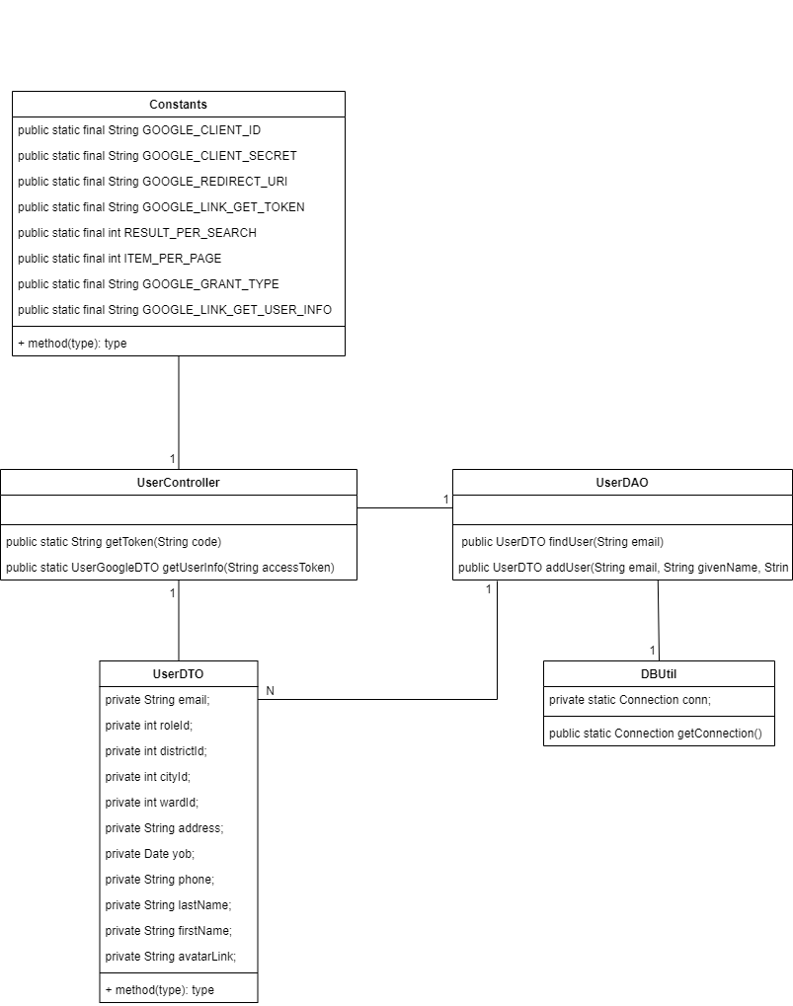

### 

### b. Class Specifications

*[Provide the description for each class and the methods in each class, following the table format as below]*

#### UserController Class

*[Provide the detailed description for the class methods]*

| **No** | **Method** | **Description** |
| --- | --- | --- |
| *01* | *public static String getToken(String code)* | *return a access token from google server* |
| *02* | *public static UserGoogleDTO getUserInfo(String accessToken)* | *use that access token to get user info from google* |

#### UserDAO Class

*[Provide the detailed description for the class methods]*

| **No** | **Method** | **Description** |
| --- | --- | --- |
| *01* | *public UserDTO findUser(String email)* | *return a user if exist in database* |
| *02* | *UserDTO addUser(String email, String givenName, String avatarLink)* | *create a user to database* |

#### 

#### DButil Class

*[Provide the detailed description for the class methods]*

| **No** | **Method** | **Description** |
| --- | --- | --- |
| *01* | *public static Connection getConnection()* | *return a database connection* |

### c. Sequence Diagram(s)

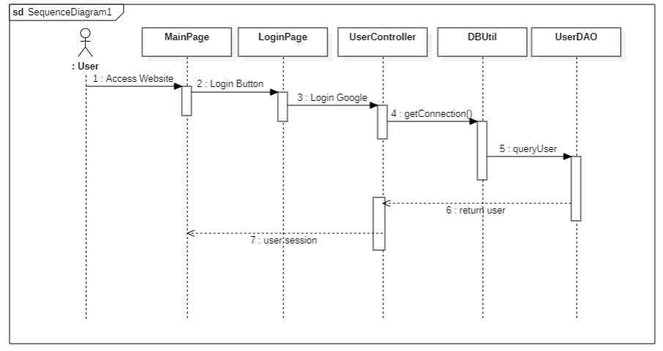

### 

### d. Database queries

UserDAO:

SELECT [email], [avatar], [first_name], [last_name], [phone], [yob], [address], [ward_id], [district_id], [city_id] , [role_id]

FROM [user] WHERE email = ?

INSERT INTO [user] (email, avatar, last_name, first_name, role_id) VALUES (?, ?, ?, ?, 0)

## 2. <SORT>

### a. Class Diagram

### 

### 

### 

### 

### 

### 

### 

### 

### 

### 

### 

### 

### 

### 

### 

### 

### 

### 

### 

### 

### 

### 

### 

### b. Class Specifications

#### Homecontroller Class

| **No** | **Method** | **Description** |
| --- | --- | --- |
| *01* | *protected void processRequest()* | *handle request from user* |

#### ProductDAO Class

| **No** | **Method** | **Description** |
| --- | --- | --- |
| *01* | *public int countProductByCateId(String cateId)* | *return total product where cateId = param* |
| *02* | *public String getFilter(int option, boolean trend)* | *return "order by” sql statement* |
| *03* | *public String getSellerEmailByProductId(String proId)* | *return a email of seller that sell a product which have a id passed in* |
| *04* | *public List<ProductDTO> getProductList(int pageNum, int option, boolean trend, int cateID)* | *return a product list base on page number, sort by option (Use the static int final variable in this class),*  *data trend (desc, asc) where category id = parameter passed in* |
| *05* | *public List<ProductDTO> getProductList(int pageNum, int option, boolean trend)* | *return a product list base on page number, sort by option (Use the static int final variable in this class),*  *data trend (desc, asc)* |
| *06* | *public List<ProductDTO> getProductList(int pageNum, int option, boolean trend, String emailSeller)* | *return a product list base on page number, sort by option (Use the static int final variable in this class),*  *data trend (desc, asc) where email of seller = parameter passed in* |
| *07* | *public List<ProductDTO> getProductList(int size, String productName)* | *get array of product base on product name and size of the array passed in* |

#### 

#### ProductImageDAO Class

| **No** | **Method** | **Description** |
| --- | --- | --- |
| *01* | *public List<ProductImageDTO> findAll(int productID)* | *find all product images of the product by productID* |

#### 

#### DButil Class

| **No** | **Method** | **Description** |
| --- | --- | --- |
| *01* | *public static Connection getConnection()* | *return a database connection* |

### 

### c. Sequence Diagram(s)

*[Provide the sequence diagram(s) for the feature, see the sample below]*

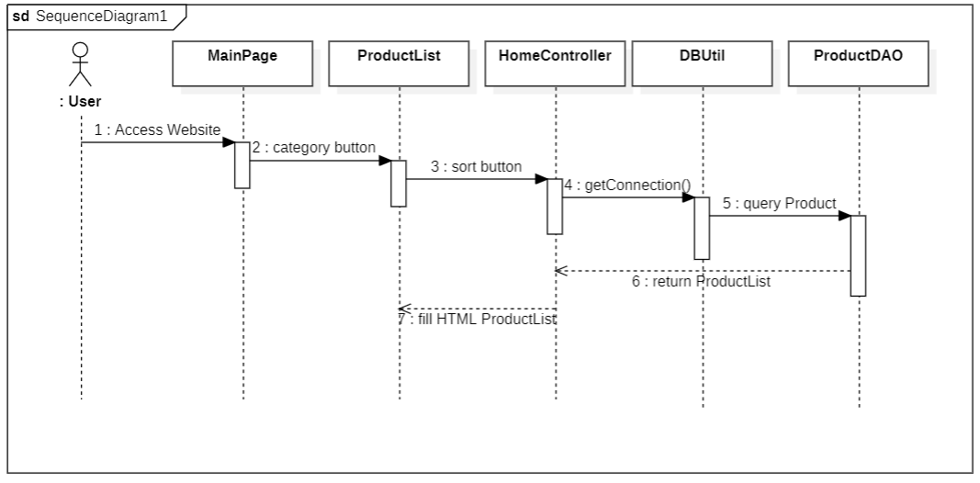

### d. Database queries

ProductDAO:

SELECT COUNT (product_id) FROMproduct WHERE category_id = ?

SELECT email_seller from product where product_id = ?

SELECT [product_id], [email_seller], [name], [price], [description], [category_id], [quantity],

[email_admin], [status], [create_at], [approve_at] , [sold_count]

FROM product WHERE category_ID = ?

SELECT [product_id], [email_seller], [name], [price], [description], [category_id], [quantity], [email_admin], [status], [create_at], [approve_at], [sold_count]

FROM product

SELECT product_id, name, price, quantity, sold_count

FROM product

WHERE email_seller = ? AND status = 1 AND quantity > 0

SELECT product_id, name FROM product

WHERE name LIKE ?

ORDER BY name OFFSET 0 rows FETCH first ? rows only

ProductImageDAO:

SELECT [image_id], [url], [is_main_img] FROM image_product WHERE product_id = ?

## 

## 

## 3. <LOAD CATEGORY>

### a. Class Diagram

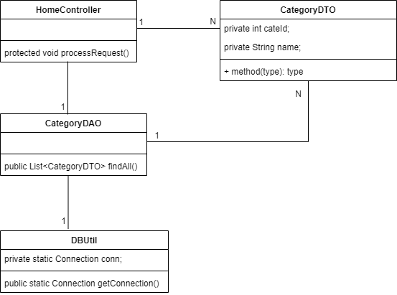

### b. Class Specifications

#### Homecontroller Class

| **No** | **Method** | **Description** |
| --- | --- | --- |
| *01* | *protected void processRequest()* | *this function is used for handle process from user* |

#### 

#### CategoryDAO Class

| **No** | **Method** | **Description** |
| --- | --- | --- |
| *01* | *public List<CategoryDTO> findAll()* | *get all list of categories* |

#### 

#### DButil Class

| **No** | **Method** | **Description** |
| --- | --- | --- |
| *01* | *public static Connection getConnection()* | *return a database connection* |

### 

### c. Sequence Diagram(s)

*[Provide the sequence diagram(s) for the feature, see the sample below*

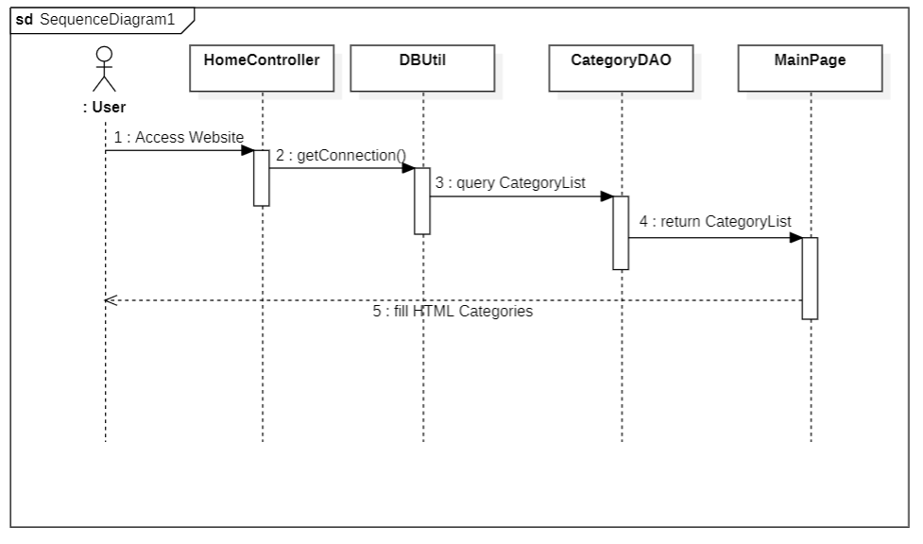

### d. Database queries

CategoryDAO:

SELECT category_id, name, icon FROM category ORDER BY category_id ASC

## 4. <SEARCH>

### a. Class Diagram

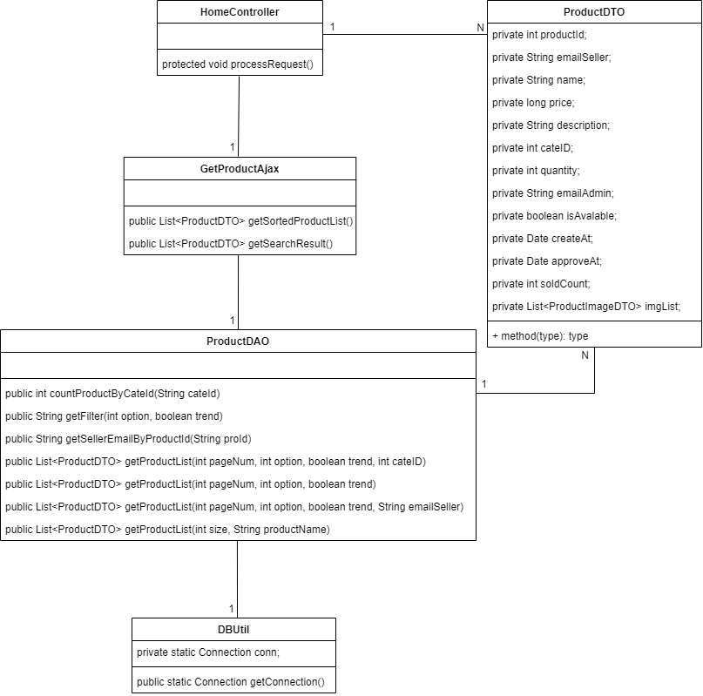

### 

### 

### 

### 

### b. Class Specifications

#### Homecontroller Class

| **No** | **Method** | **Description** |
| --- | --- | --- |
| *01* | *protected void processRequest()* | *this function is used for handle process from user* |

#### 

#### GetProductAjax Class

| **No** | **Method** | **Description** |
| --- | --- | --- |
| *01* | *public List<ProductDTO>getSortedProductList()* | *get sorted product list (base on parameter of the request)* |
| *02* | *public List<ProductDTO>getSearchResult()* | *return a list of product(product name and product id) when user typing something to search* |

#### 

#### ProductDAO Class

| **No** | **Method** | **Description** |
| --- | --- | --- |
| *01* | *public int countProductByCateId(String cateId)* | *get total product base on category id for paging* |
| *02* | *public String getFilter(int option, boolean trend)* | *return “order by” sql statement* |
| *03* | *public String getSellerEmailByProductId(String proId)* | *return a email of seller that sell a product which have a id passed in* |
| *04* | *public List<ProductDTO> getProductList(int pageNum, int option, boolean trend, int cateID)* | *return a product list base on page number, sort by option (Use the static int final variable in this class),*  *data trend (desc, asc) where category id = parameter passed in* |
| *05* | *public List<ProductDTO> getProductList(int pageNum, int option, boolean trend)* | *return a product list base on page number, sort by option (Use the static int final variable in this class),*  *data trend (desc, asc)* |
| *06* | *public List<ProductDTO> getProductList(int pageNum, int option, boolean trend, String emailSeller)* | *return a product list base on page number, sort by option (Use the static int final variable in this class),*  *data trend (desc, asc) where email of seller = parameter passed in* |
| *07* | *public List<ProductDTO> getProductList(int size, String productName)* | *get array of product base on product name and size of the array passed in* |

#### 

#### DButil Class

| **No** | **Method** | **Description** |
| --- | --- | --- |
| *01* | *public static Connection getConnection()* | *return a sql Connection object* |

### c. Sequence Diagram(s)

*[Provide the sequence diagram(s) for the feature, see the sample below]*

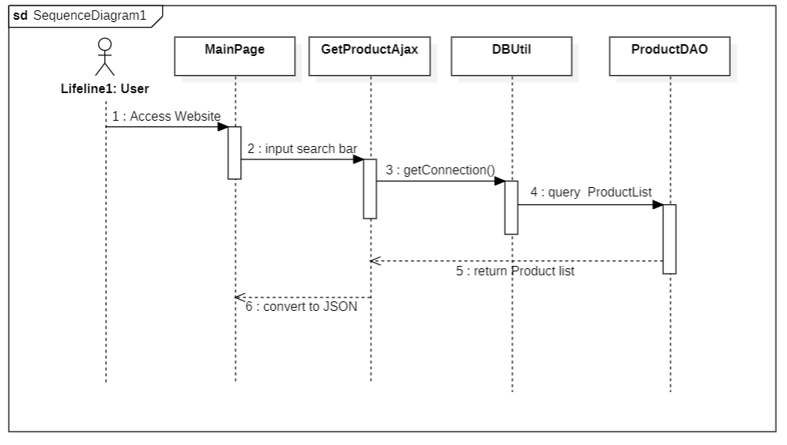

### d. Database queries

ProductDAO

SELECT count(product_id) FROM product WHERE category_id = ?

SELECT email_seller FROM product WHERE product_id = ?

SELECT [product_id], [email_seller], [name], [price], [description], [category_id], [quantity], [email_admin], [status], [create_at], [approve_at] , [sold_count]

FROM product WHERE category_ID = ?

SELECT [product_id], [email_seller], [name], [price], [description], [category_id], [quantity], [email_admin], [status], [create_at], [approve_at], [sold_count]

FROM product

SELECT product_id, name, price, quantity, sold_count FROM product

WHERE email_seller = ? AND status = 1 AND quantity > 0

SELECT product_id, name

FROM product

WHERE name LIKE ?

ORDER BY name OFFSET 0 rows FETCH first ? rows only

## 

## 5. <PRODUCT DETAIL>

### a. Class Diagram

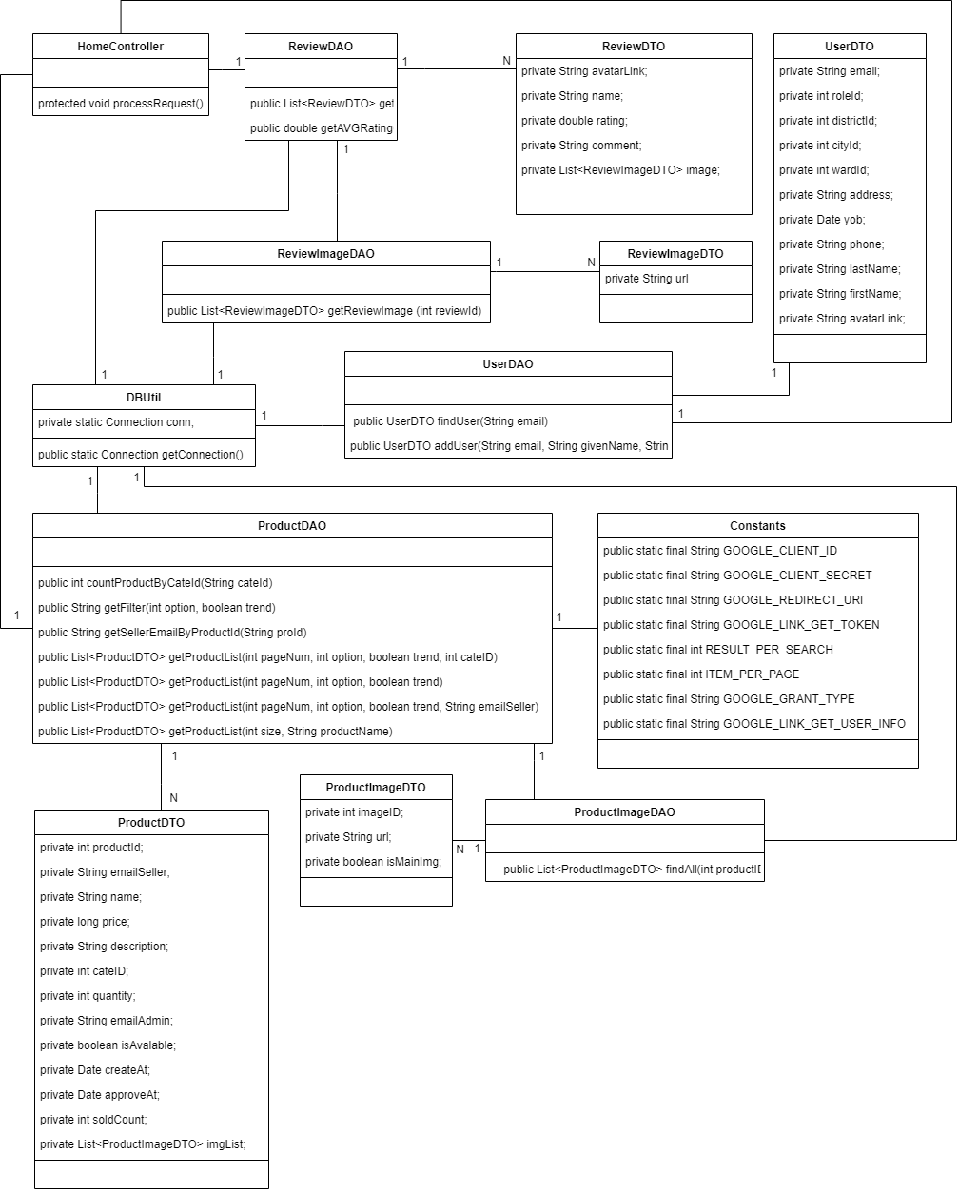

### b. Class Specifications

#### HomeController Class

| **No** | **Method** | **Description** |
| --- | --- | --- |
| *01* | *protected void processRequest()* | *take request and redirect to specified product* |

#### 

#### ReviewDAO Class

| **No** | **Method** | **Description** |
| --- | --- | --- |
| *01* | *public List<ReviewDTO> getReview(int productId)* | *show all review of product* |
| *02* | *public double getAVGRatingOfProduct(int productId)* | *show average rating of product* |

#### 

#### ReviewImageDAO Class

| **No** | **Method** | **Description** |
| --- | --- | --- |
| *01* | *public List<ReviewImageDTO> getReviewImage (int reviewId)* | *get all images of a reviewer for product* |

#### 

#### UserDAO Class

| **No** | **Method** | **Description** |
| --- | --- | --- |
| *01* | *public UserDTO findUser(String email)* | *get information of seller* |
|  | *public UserDTO addUser(String email, String givenName, String avatarLink)* | *insert a data user into database* |

#### 

#### ProductDAO Class

| **No** | **Method** | **Description** |
| --- | --- | --- |
| *01* | *public int countProductByCateId(String cateId)* | *get total product base on category id for paging* |
| *02* | *public String getFilter(int option, boolean trend)* | *return “order by” sql statement* |
| *03* | *public String getSellerEmailByProductId(String proId)* | *return an email of seller that sell a product which have an id passed in* |
| *04* | *public List<ProductDTO> getProductList(int pageNum, int option, boolean trend, int cateID)* | *return a product list base on page number, sort by option (Use the static int final variable in this class),*  *data trend (desc, asc) where category id = parameter passed in* |
| *05* | *public List<ProductDTO> getProductList(int pageNum, int option, boolean trend)* | *return a product list base on page number, sort by option (Use the static int final variable in this class),*  *data trend (desc, asc)* |
| *06* | *public List<ProductDTO> getProductList(int pageNum, int option, boolean trend, String emailSeller)* | *return a product list base on page number, sort by option (Use the static int final variable in this class),*  *data trend (desc, asc) where email of seller = parameter passed in* |
| *07* | *public List<ProductDTO> getProductList(int size, String productName)* | *get array of product base on product name and size of the array passed in* |

#### 

#### ProductImageDAO Class

| **No** | **Method** | **Description** |
| --- | --- | --- |
| *01* | *public List<ProductImageDTO> findAll(int productID)* | *get all images of product* |

#### 

#### DButil Class

| **No** | **Method** | **Description** |
| --- | --- | --- |
| *01* | *public static Connection getConnection()* | *create connection between project and database* |

### c. Sequence Diagram(s)

*[Provide the sequence diagram(s) for the feature, see the sample below]*

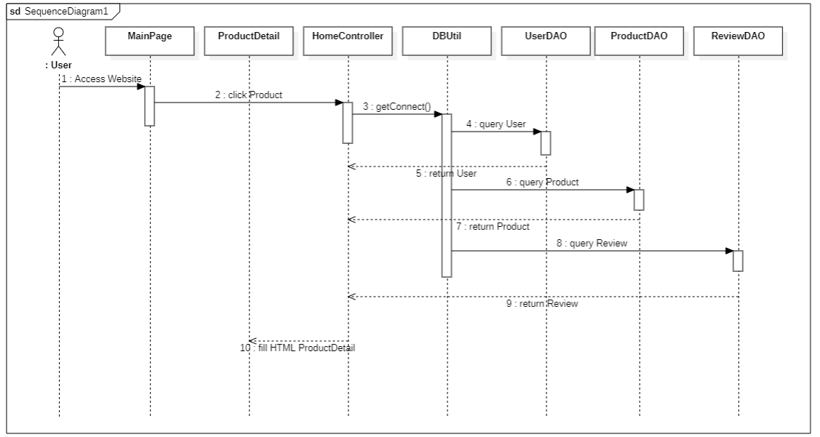

### 

### d. Database queries

ReviewImageDAO:

SELECT url FROM image_review WHERE review_id = ? ORDER BY image_id

UserDAO:

SELECT [email], [avatar], [first_name], [last_name], [phone], [yob], [address], [ward_id], [district_id], [city_id], [role_id]

FROM [user] WHERE email = ?

INSERT INTO [user] (email, avatar, last_name, first_name, role_id) VALUES (?, ?, ?, ?, 0)

ProductDAO:

SELECT COUNT(product_id) FROM product WHERE category_id = ?

SELECT email_seller FROM product WHERE product_id = ?

SELECT [product_id], [email_seller], [name], [price], [description], [category_id], [quantity], [email_admin], [status], [create_at], [approve_at] , [sold_count]

FROM product WHERE category_ID = ?

SELECT [product_id], [email_seller], [name], [price], [description], [category_id], [quantity], [email_admin], [status], [create_at], [approve_at], [sold_count] FROM product

SELECT product_id, name, price, quantity, sold_count FROM product

WHERE email_seller = ? AND status = 1 AND quantity > 0

SELECT product_id, name FROM product

WHERE name LIKE ? ORDER BY name OFFSET 0 rows FETCH first ? rows only

ProductDAO:

SELECT url FROM image_review WHERE review_id = ? ORDER BY image_id

## 6. <BUY PRODUCT>

### a. Class Diagram

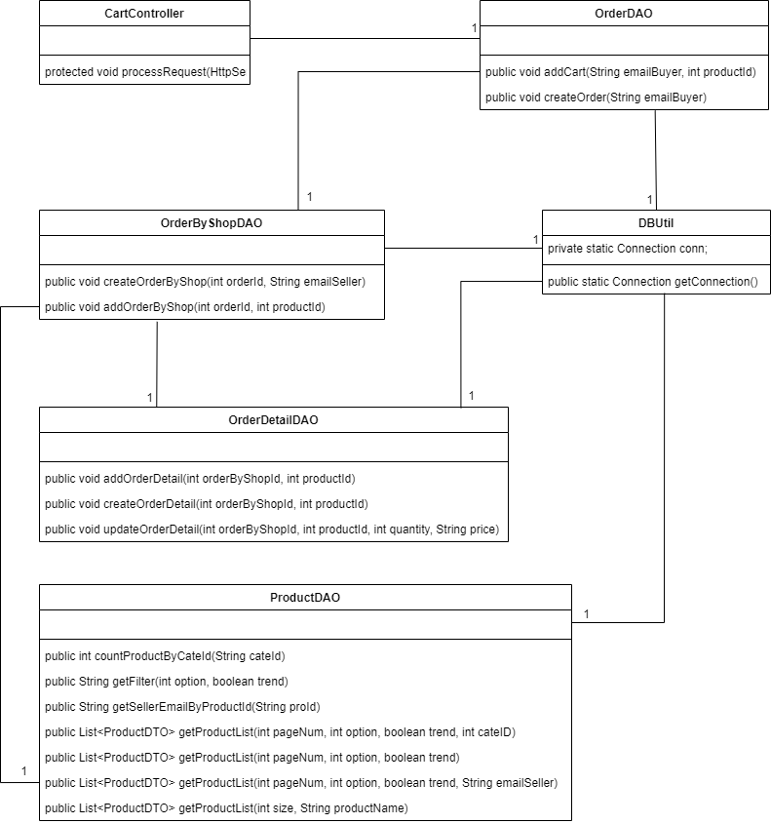

### 

### b. Class Specifications

#### CartController Class

| **No** | **Method** | **Description** |
| --- | --- | --- |
| *01* | *public List<ProductImageDTO> findAll(int productID)* | *Receive and process requests from users to add products to the order* |

### 

#### OrderDAO Class

| **No** | **Method** | **Description** |
| --- | --- | --- |
| *01* | *public void addCart(String emailBuyer, int productId)* | *check the existence or create a new order* |
| *02* | *public void createOrder(String emailBuyer)* | *create a new order* |

### 

#### OrderByShopDAO Class

| **No** | **Method** | **Description** |
| --- | --- | --- |
| *01* | *public void createOrderByShop(int orderId, String emailSeller)* | *check the existence or create a new order by shop* |
| *02* | *public void addOrderByShop(int orderId, int productId)* | *create a new order by shop* |

### 

#### OrderDetailDAO Class

| **No** | **Method** | **Description** |
| --- | --- | --- |
| *01* | *public void addOrderDetail(int orderByShopId, int productId)* | *check the existence or create a new order detail or update order detail* |
| *02* | *public void createOrderDetail(int orderByShopId, int productId)* | *create a new order detail* |
| *03* | *public void updateOrderDetail(int orderByShopId, int productId, int quantity, String price)* | *update to increase the number of products by 1 in the order* |

### 

#### ProductDAO Class

| **No** | **Method** | **Description** |
| --- | --- | --- |
| *01* | *public int countProductByCateId(String cateId)* | *get total product base on category id for paging* |
| *02* | *public String getFilter(int option, boolean trend)* | *return “order by” sql statement* |
| *03* | *public String getSellerEmailByProductId(String proId)* | *return an email of seller that sell a product which have a id passed in* |
| *04* | *public List<ProductDTO> getProductList(int pageNum, int option, boolean trend, int cateID)* | *return a product list base on page number, sort by option (Use the static int final variable in this class),*  *data trend (desc, asc) where category id = parameter passed in* |
| *05* | *public List<ProductDTO> getProductList(int pageNum, int option, boolean trend)* | *return a product list base on page number, sort by option (Use the static int final variable in this class),*  *data trend (desc, asc)* |
| *06* | *public List<ProductDTO> getProductList(int pageNum, int option, boolean trend, String emailSeller)* | *return a product list base on page number, sort by option (Use the static int final variable in this class),*  *data trend (desc, asc) where email of seller = parameter passed in* |
| *07* | *public List<ProductDTO> getProductList(int size, String productName)* | *get array of product base on product name and size of the array passed in* |

#### 

#### 

#### DButil Class

| **No** | **Method** | **Description** |
| --- | --- | --- |
| *01* | *public static Connection getConnection()* | *create connection between project and database* |

### c. Sequence Diagram(s)

*[Provide the sequence diagram(s) for the feature, see the sample below]*

### 

### 

### d. Database queries

ProductDAO:

SELECT product_idemail_seller, name, price, description, category_id, quantity, sold_count FROM product WHERE product_id = ? AND status = 1

SELECT product_id, name, price, quantity, sold_count

FROM product WHERE email_seller = ? AND status = 1 AND quantity > 0

ORDER BY sold_count DECS OFFSET itemSkipped ROWS FETCH NEXT 8 ROWS ONLY

UserDAO:

SELECT email, avatar, first_name, last_name, phone, address, w.name, d.name, c.name

FROM [user] u LEFT JOIN ward w ON u.ward_id = w.ward_id

LEFT JOIN district d ON u.district_id = d.district_id

LEFT JOIN city c ON u.city_id = c.city_id

WHERE email = (SELECT email_seller

FROM product

WHERE product_id = ? )

ReviewDAO:

SELECT u.avatar, u.first_name, u.last_name, r.comment, r.rating, r.review_id

FROM [user] u RIGHT JOIN [order] od ON u.email = od.email_buyer

RIGHT JOIN order_by_shop os ON od.order_id = os.order_id

RIGHT JOIN (SELECT order_detail_id, order_by_shop_id

FROM [order_detail]

WHERE product_id = ?) o ON os.order_by_shop_id = o.order_by_shop_id

LEFT JOIN review r ON r.order_detail_id = o.order_detail_id

ORDER BY r.review_id

SELECT AVG(r.rating)

FROM [order_detail] o LEFT JOIN review r ON r.order_detail_id = o.order_detail_id

WHERE product_id = ?

## 7. <BANNER>

### a. Class Diagram

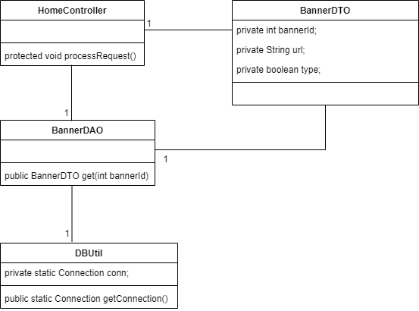

### b. Class Specifications

#### HomeController Class

| **No** | **Method** | **Description** |
| --- | --- | --- |
| *01* | *protected void processRequest()* | *receive request and redirect to specific page* |

#### 

#### BannerDAO Class

| **No** | **Method** | **Description** |
| --- | --- | --- |
| *01* | *public BannerDTO get(int bannerId)* | *get all data of a banner* |

### 

#### DButil Class

| **No** | **Method** | **Description** |
| --- | --- | --- |
| *01* | *public static Connection getConnection()* | *create connection between project and database* |

### 

### c. Sequence Diagram(s)

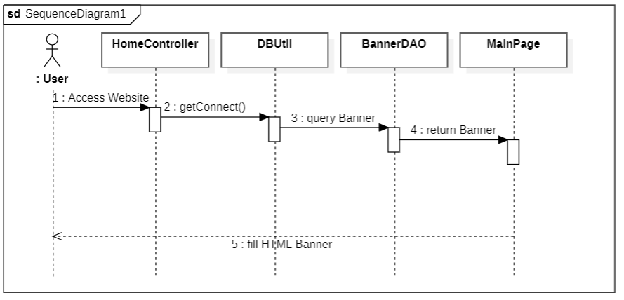

### d. Database queries

BannerDAO:

SELECT banner_id, url, type_banner FROM banner WHERE banner_id = ?

## 8. <PRODUCT AUTHENTICATION>

### a. Class Diagram

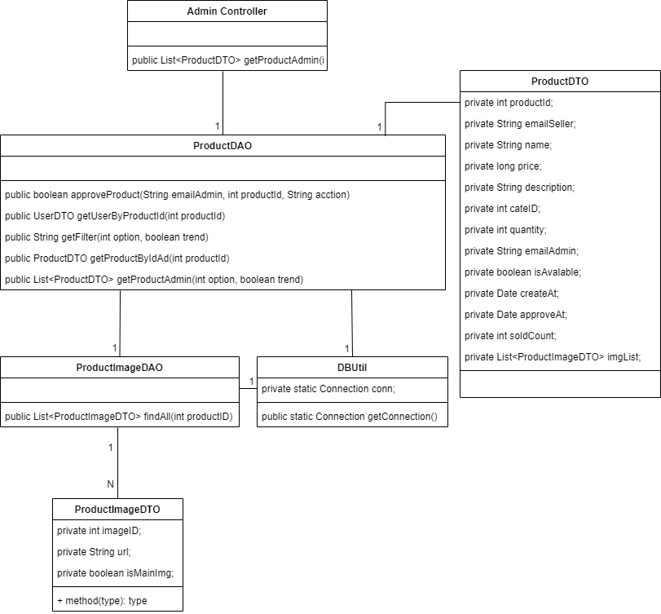

### b. Class Specifications

#### Admin Controller Class

| **No** | **Method** | **Description** |
| --- | --- | --- |
| *01* | *public List <ProductDTO> getProductAdmin()* | *Receive and process requests from admin and sub admin to product censorship* |

#### 

#### 

#### ProductDAO Class

| **No** | **Method** | **Description** |
| --- | --- | --- |
| *01* | *public boolean approveProduct(String emailAdmin, int productId, String action)* | *approve action, update product data* |
| *02* | *public String getFilter(int option, boolean trend)* | *get filter sort by day (approve_at, create_at)* |
| *03* | *public ProductDTO getProductByIdAd(int productId)* | *get product detail by id for admin preview* |
| *04* | *public List<ProductDTO> getProductAdmin(int option, boolean trend)* | *get new product list for admin to authentication* |

#### 

#### ProductImageDAO Class

| **No** | **Method** | **Description** |
| --- | --- | --- |
| *01* | *public List<ProductImageDTO> findAll(int productID)* | *get all images of a product* |

#### 

#### 

### c. Sequence Diagram(s)

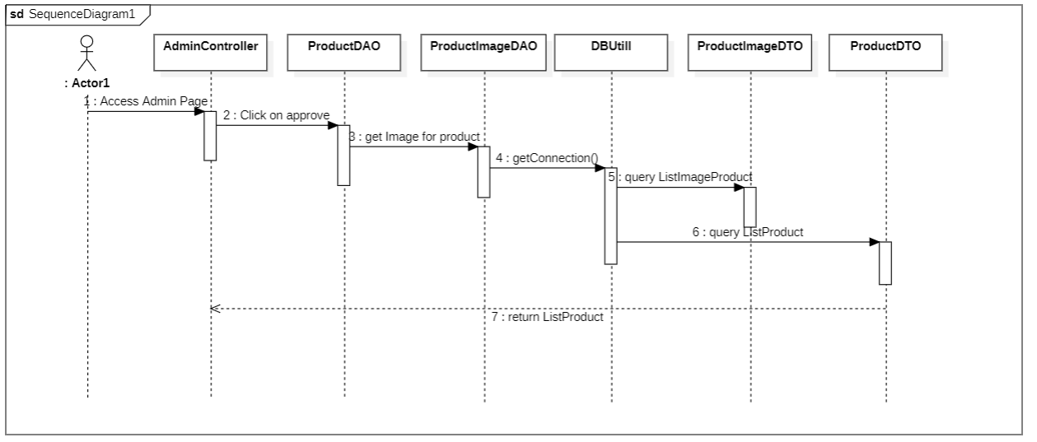

### d. Database queries

ProductDAO:

UPDATE [dbo].[product] SET email_admin = emailAdmin, approve_at java.sql.Date.valueOf(LocalDate.now()).toString(), status = WHERE product_id = " + productId

SELECT email, avatar, first_name, last_name, phone, address, w.name, d.name, c.name FROM [user] u LEFT JOIN ward w ON u.ward_id = w.ward_id

LEFT JOIN district d ON u.district_id = d.district_id

LEFT JOIN city c ON u.city_id = c.city_id WHERE email = (SELECT email_seller FROM product WHERE product_id = ? )

SELECT [product_id], [email_seller], [name],[price], [description], [category_id], [quantity], [sold_count] FROM product WHERE product_id = ? AND email_admin is not null

SELECT [product_id], [email_seller], [name], [price], [description], [category_id], [quantity], [create_at] FROM product WHERE email_admin is null AND status is null

ProdutImageDAO:

select [image_id], [url], [is_main_img] from image_product where product_id = ?

## 9. <DELETE PRODUCT ON WEBSITE>

### a. Class Diagram

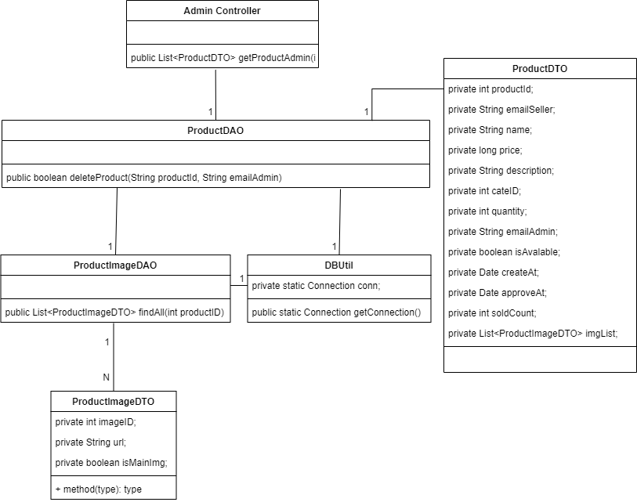

### b. Class Specifications

#### Admin Controller Class

| **No** | **Method** | **Description** |
| --- | --- | --- |
| *01* | *public List <ProductDTO> getProductAdmin()* | *Receive and process requests from admin and sub admin to product censorship* |

#### 

#### ProductDAO Class

| **No** | **Method** | **Description** |
| --- | --- | --- |
| *01* | *public boolean deleteProduct(String productId, String emailAdmin)* | *delete product* |

#### 

#### ProductImgaeDAO Class

| **No** | **Method** | **Description** |
| --- | --- | --- |
| *01* | *public List<ProductImageDTO> findAll(int productID)* | *find all images of product* |

#### 

#### 

#### DBUtil Class

| **No** | **Method** | **Description** |
| --- | --- | --- |
| *01* | *public static Connection getConnection()* | *create connection between project and database* |

#### 

### c. Sequence Diagram(s)

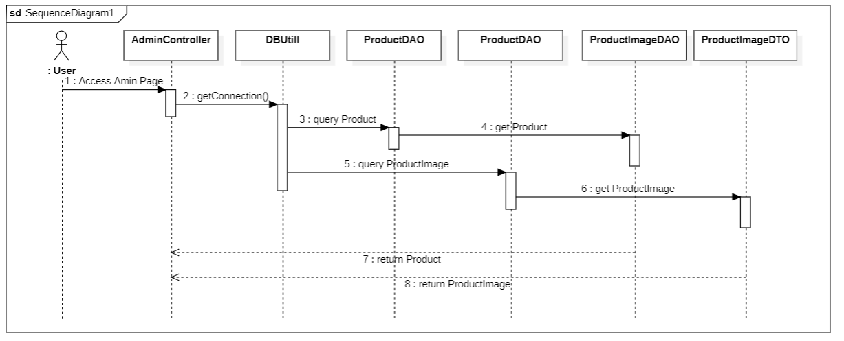

### d. Database queries

ProductDAO:

UPDATE [dbo].[product] set status = 0, email_admin = ? WHERE product_id = ?

ProdutImageDAO:

select [image_id], [url], [is_main_img] from image_product where product_id = ?

## 10. <[DASHBOARD](https://docs.google.com/document/d/1e0yA5Z7L8BlFa-ovUPd5vcr6bQ8bFkrO/edit#heading=h.9ix3ptkixfcr)>

### a. Class Diagram

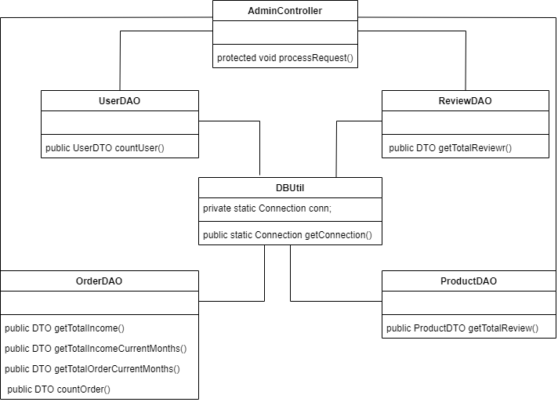

### b. Class Specifications

#### 

#### DBUtil Class

| **No** | **Method** | **Description** |
| --- | --- | --- |
| *01* | *public static Connection getConnection()* | *create connection between project and database* |

#### 

#### AdminController Class

| **No** | **Method** | **Description** |
| --- | --- | --- |
| *01* | *protected void processRequest()* | *Receive and process requests from admins and sub-admins to get to the dashboard page* |

#### 

#### 

#### OrderDAO Class

| **No** | **Method** | **Description** |
| --- | --- | --- |
| *01* | *public int getTotalIncome()* | *get total income of the system at all time* |
| *02* | *public ArrayList<Integer> getTotalOrderCurrentMonths(int monthNumber)* | *get array of number of orders in number of month parameter passed in* |
| *03* | *public ArrayList<Integer> getTotalIncomeCurrentMonths(int monthNumber)* | *get array of number of income of the system in recent [month number] parameter passed in* |
| *04* | *public int countOrder()* | *count order* |

#### 

#### UserDAO Class

| **No** | **Method** | **Description** |
| --- | --- | --- |
| *01* | *public int countUser()* | *return total user in the system* |

#### 

#### ReviewDAO Class

| **No** | **Method** | **Description** |
| --- | --- | --- |
| *01* | *public int getTotalReview(int month)* | *return total review in the system* |

#### 

#### ProductDAO Class

| **No** | **Method** | **Description** |
| --- | --- | --- |
| *01* | *public ProductDTO getTotalReview()* |  |

#### 

#### 

### c. Sequence Diagram(s)

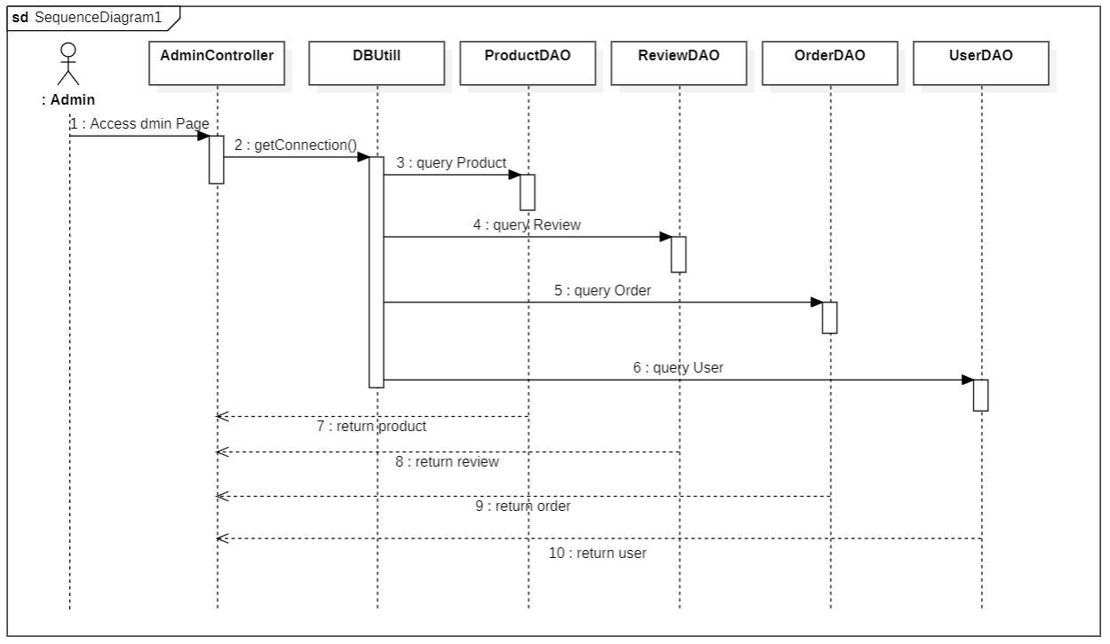

### d. Database queries

UserDAO:

select count(email) from [dbo].[user]

ReviewDAO:

select count(review.review_id) from review where month([date])= ?

OrderDAO:

SELECT SUM(od.price) (FROM SELECT order_id FROM [order] WHERE MONTH([order_date]) = ?) o LEFT JOIN order_by_shop os ON o.order_id = os.order_id LEFT JOIN order_detail od ON od.order_by_shop_id = os.order_by_shop_id

SELECT SUM(od.price) FROM (SELECT order_id FROM [order]) o LEFT JOIN order_by_shop os ON o.order_id = os.order_id LEFT JOIN order_detail od ON od.order_by_shop_id = os.order_by_shop_id

SELECT max([order_id]) FROM [FEP_DB].[dbo].[order] where status = 1

Select count(order_id) from dbo.[order] where month(order_date) = ?

## 11. <[REVIEW AUTHENTICATION](https://docs.google.com/document/d/1e0yA5Z7L8BlFa-ovUPd5vcr6bQ8bFkrO/edit#heading=h.muud4yv7wd2u)>

### a. Class Diagram

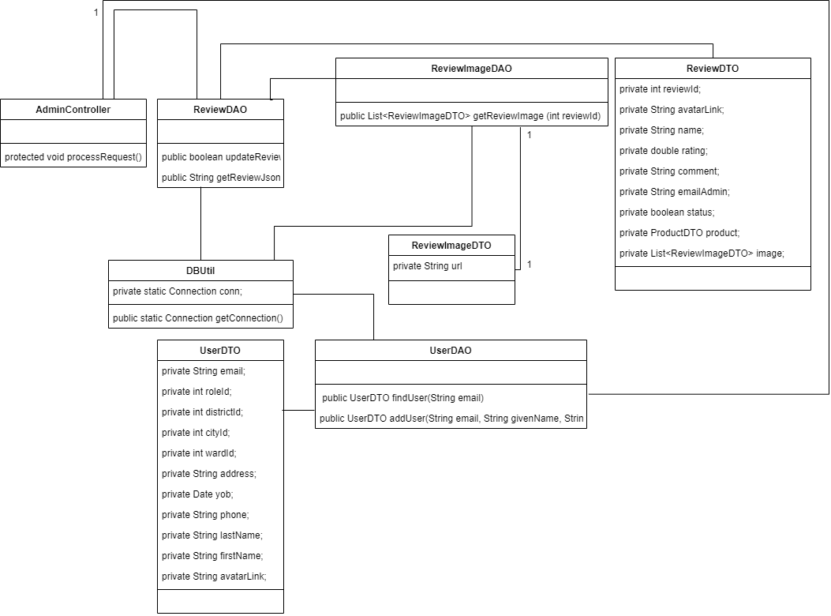

### b. Class Specifications

#### AdminController Class

| **No** | **Method** | **Description** |
| --- | --- | --- |
| *01* | *protected void processRequest()* | *Receive and process requests from users to censor review list* |

#### 

#### ReviewDAO Class

| **No** | **Method** | **Description** |
| --- | --- | --- |
| *01* | *public boolean updateReview()* | *update status of a review* |
| *02* | *public String getReviewJson()* | *convert data to output to datatable* |

#### 

#### DBUtil Class

| **No** | **Method** | **Description** |
| --- | --- | --- |
| *01* | *public static Connection getConnection()* | *create connection between project and database* |

#### 

#### ReviewImageDAO Class

| **No** | **Method** | **Description** |
| --- | --- | --- |
| *01* | *public List<ReviewImageDTO> getReviewImage (int reviewId)* | *get all image of a review* |

#### 

#### UserDAO Class

| **No** | **Method** | **Description** |
| --- | --- | --- |
| *01* | *public UserDTO findUser(String email)* | *retrieve users who have written reviews* |

#### 

### c. Sequence Diagram(s)

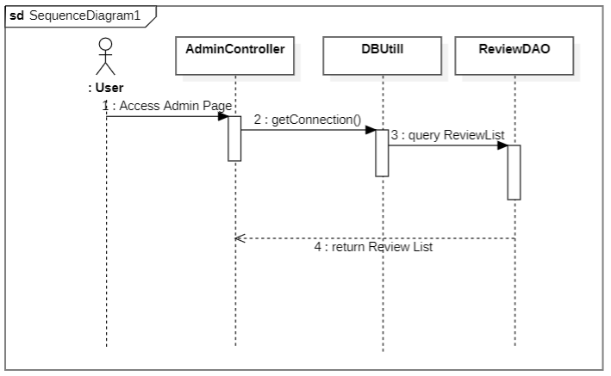

### d. Database queries

ReviewDAO:

UPDATE review SET email_admin = ?, status = ? WHERE review_id = ?

UserDAO:

select [email], [avatar], [first_name], [last_name], [phone], [yob], [address], [ward_id], [district_id], [city_id], [role_id] from [user] where email = ?

insert into [user] (email, avatar, last_name, first_name, role_id) values (?, ?, ?, ?, 0)

ProdutImageDAO:

select [image_id], [url], [is_main_img] from image_product where product_id = ?

## 12. <[DELETE REVIEW ON WEBSITE](https://docs.google.com/document/d/1e0yA5Z7L8BlFa-ovUPd5vcr6bQ8bFkrO/edit#heading=h.bfznjt2c410v)>

### a. Class Diagram



### b. Class Specifications

#### AdminController Class

| **No** | **Method** | **Description** |
| --- | --- | --- |
| *01* | *protected void processRequest()* | *Receive and process requests from users to delete review on website* |

#### 

#### 

#### ReviewDAO Class

| **No** | **Method** | **Description** |
| --- | --- | --- |
| *01* | *public boolean updateReview()* | *Review moderation status update* |
| *02* | *public String getReviewJson()* | *convert data to output to datatable* |

#### DBUtil Class

| **No** | **Method** | **Description** |
| --- | --- | --- |
| *01* | *public static Connection getConnection()* | *create connection between project and database* |

#### 

#### ReviewImageDAO Class

| **No** | **Method** | **Description** |
| --- | --- | --- |
| *01* | *public List<ReviewImageDTO> getReviewImage (int reviewId)* | *get all photos of each review* |

#### 

#### UserDAO Class

| **No** | **Method** | **Description** |
| --- | --- | --- |
| *01* | *public UserDTO findUser(String email)* | *retrieve users who have written reviews* |

#### 

### c. Sequence Diagram(s)



### 

### d. Database queries

ReviewDAO:

UPDATE review SET email_admin = ?, status = ? WHERE review_id = ?

ReviewImageDAO:

SELECT url FROM image_review WHERE review_id = ? ORDER BY image_id

UserDAO:

select [email], [avatar], [first_name], [last_name], [phone], [yob], [address], [ward_id], [district_id], [city_id], [role_id] from [user] where email = ?

insert into [user] (email, avatar, last_name, first_name, role_id) values (?, ?, ?, ?, 0)

## 13. <PROMOTE ROLE>

### a. Class Diagram

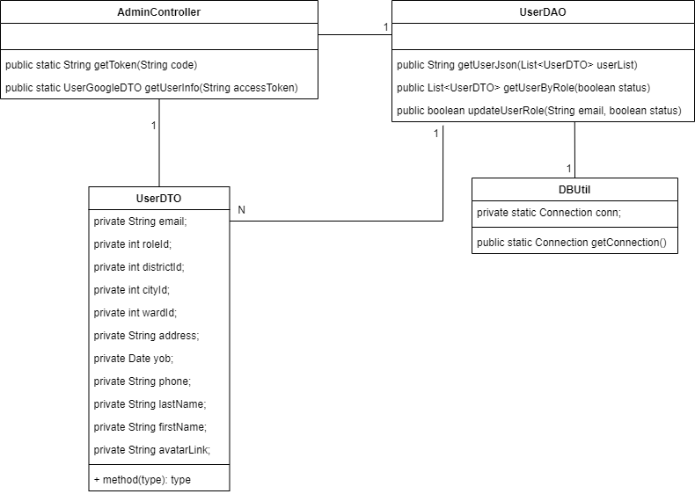

### 

### b. Class Specifications

#### AdminController Class

| **No** | **Method** | **Description** |
| --- | --- | --- |
| *01* | *public static UserGoogleDTO getUserInfo(String accessToken)* | *Receive and process requests from users to update user role* |

#### 

#### UserDAO Class

| **No** | **Method** | **Description** |
| --- | --- | --- |
| *01* | *public String getUserJson(List<UserDTO> userList)* | *convert data to output to datatable* |
| *02* | *public List<UserDTO> getUserByRole(boolean status)* | *get list user to update role* |
| *03* | *public boolean updateUserRole(String email, boolean status)* | *update role* |

#### 

#### DBUtil Class

| **No** | **Method** | **Description** |
| --- | --- | --- |
| *01* | *public static Connection getConnection()* | *create connection between project and database* |

#### 

### c. Sequence Diagram(s)

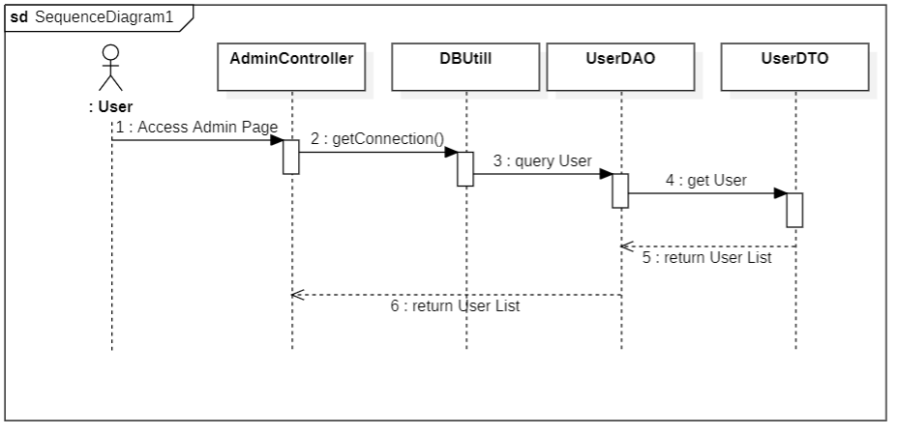

### 

### d. Database queries

UserDAO:

SELECT [email],[avatar], [first_name], [last_name], [phone], [role_id] FROM [user] WHERE role_id = ?

UPDATE [user] SET role_id = ? WHERE email = ?

## 14. <[CREATE NEW PRODUCT](https://docs.google.com/document/d/1e0yA5Z7L8BlFa-ovUPd5vcr6bQ8bFkrO/edit#heading=h.wwllibadfayc)>

### a. Class Diagram

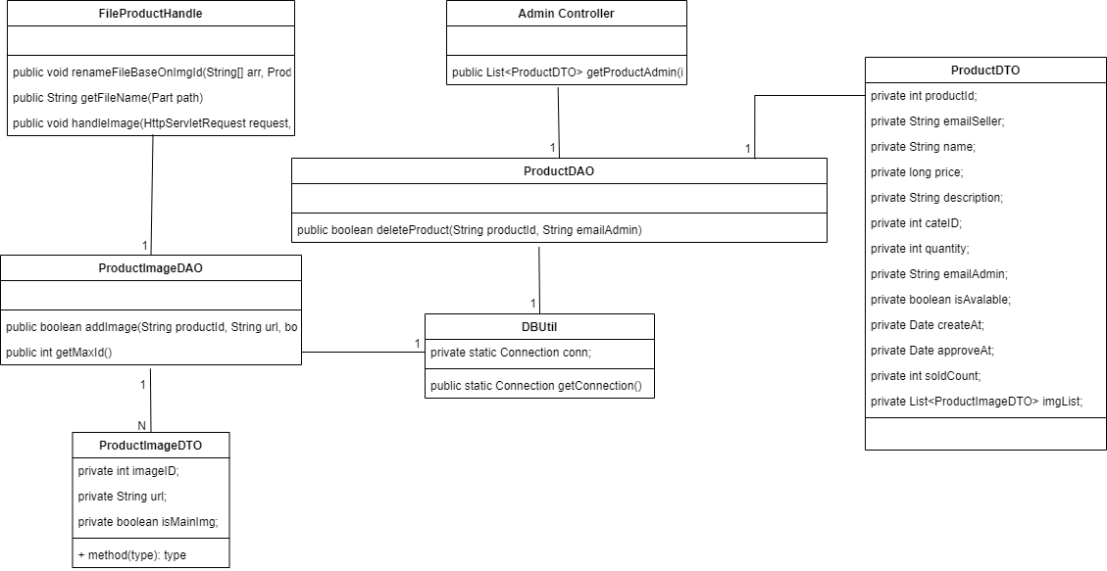

### b. Class Specifications

#### ProductImageDAO Class

| **No** | **Method** | **Description** |
| --- | --- | --- |
| *01* | *public boolean addImage(String productId)* | *add image to the database* |
| *02* | *public int getMaxId()* | *get max id of the product table* |

#### 

#### DBUtil Class

| **No** | **Method** | **Description** |
| --- | --- | --- |
| *01* | *public static Connection getConnection()* | *create connection between project and database* |

#### 

#### 

### c. Sequence Diagram(s)

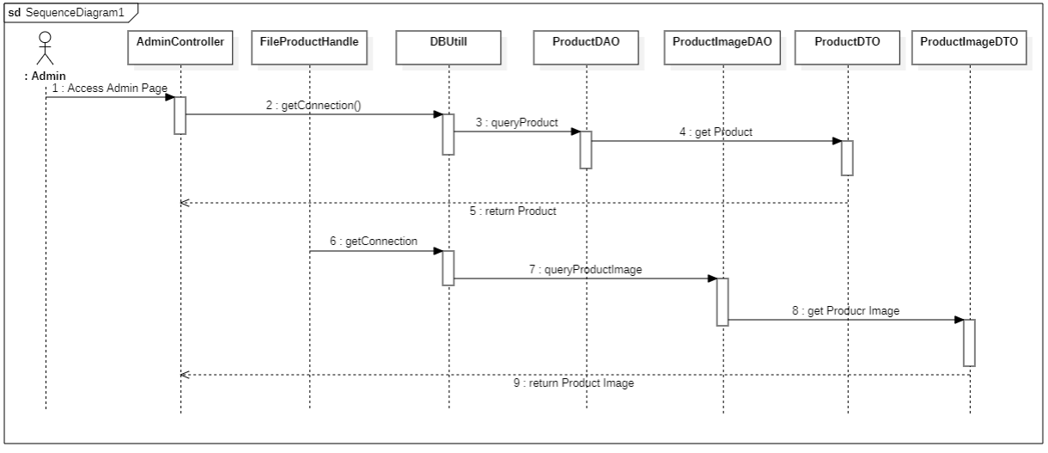

### d. Database queries

ProductDAO:

UPDATE [dbo].[product] set status = 0, email_admin = ? WHERE product_id = ?

ProductImageDAO:

INSERT INTO [dbo].[image_product] ([product_id], [url], [is_main_img] ) VALUES (? , ? , ?)

select max(image_id) from image_product

## 15. <CART>

### a. Class Diagram

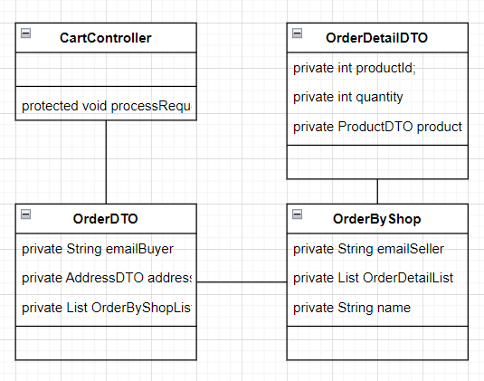

### b. Class Specifications

#### CartController Class

| **No** | **Method** | **Description** |
| --- | --- | --- |
| *01* | *protected void processRequest(HttpServletRequest request, HttpServletResponse response)* | *update and store data on session* |

### c. Sequence Diagram(s)

### 

### 

### d. Database queries

OrderDAO:

SELECT order_id FROM [order] WHERE email_buyer = ? AND [status] = 0

INSERT INTO [order] (email_buyer) VALUES (?)

OrderByShopDAO:

INSERT INTO [order_by_shop] (order_id, email_seller) VALUES (?, ?)

SELECT order_by_shop_id FROM order_by_shop WHERE order_id = ? AND email_seller = ?

OrderDetailDAO:

SELECT quantity FROM [order_detail] WHERE order_by_shop_id = ? AND product_id = ?

INSERT INTO [order_detail] (order_by_shop_id, product_id) VALUES (?, ?)

UPDATE order_detail SET quantity = ? , price = ? WHERE order_by_shop_id = ? AND product_id = ?

ProductDAO:

select count(product_id) from product where category_id = ?

select email_seller from product where product_id = ?

select product_id, name from product where name like ? order by name offset 0 rows fetch first ? rows only

select [product_id], [email_seller], [name], [price], [description], [category_id], [quantity], [email_admin], [status], [create_at], [approve_at], [sold_count] from product where category_ID = ?

SELECT product_id, name, price, quantity, sold_count FROM product WHERE email_seller = ? AND status = 1 AND quantity > 0

select [product_id], [email_seller], [name], [price], [description], [category_id], [quantity], [email_admin], [status], [create_at], [approve_at], [sold_count] from product where category_ID = ?

## 16. <[USER DETAIL](https://docs.google.com/document/d/1e0yA5Z7L8BlFa-ovUPd5vcr6bQ8bFkrO/edit#heading=h.msptmc6amvik)>

### a. Class Diagram

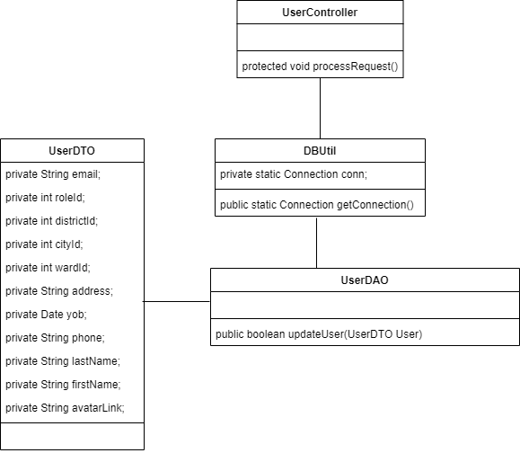

### b. Class Specifications

#### 

#### UserDAO Class

| **No** | **Method** | **Description** |
| --- | --- | --- |
| *01* | *public boolean updateUser(UserDTO user)* | *update user information to the database* |

#### 

#### 

#### DBuitlClass

| **No** | **Method** | **Description** |
| --- | --- | --- |
| *01* | *public static Connection getConnection()* | *create connection between project and database* |

#### 

#### 

#### UserControllerClass

| **No** | **Method** | **Description** |
| --- | --- | --- |
| *01* | *protected void processRequest(HttpServletRequest request, HttpServletResponse response)* | *handle requests* |

#### 

### c. Sequence Diagram(s)

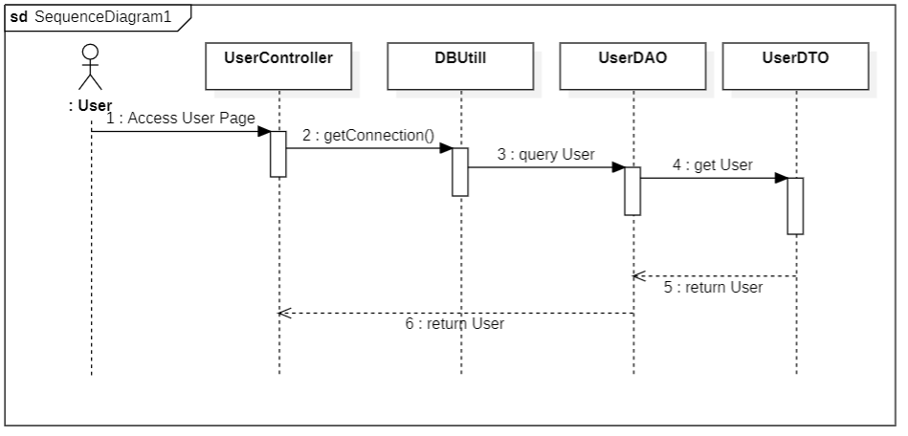

### d. Database queries

## 

UserDAO:

update [user] set [first_name] = ?,

[last_name] = ? ,

[phone] = ? ,

[yob] = ? ,

[address] = ? ,

[ward_id] = ? ,

[district_id] = ? ,

[city_id] = ? ,

where [email] = ?

## 17. <SHOP PAGE>

### a. Class Diagram

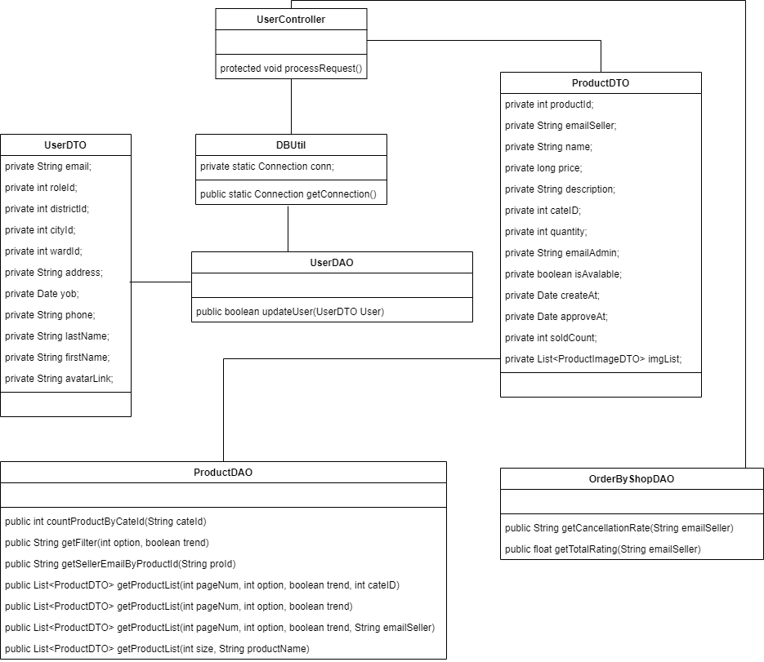

### b. Class Specifications

#### 

#### UserDAO

| **No** | **Method** | **Description** |
| --- | --- | --- |
| *01* | *public boolean updateUser(UserDTO User)* | *update user* |

#### 

#### OrderByShopDAO

| **No** | **Method** | **Description** |
| --- | --- | --- |
| *01* | *public String getCancellationRate(String emailSeller)* | *get cancellation order rate of a seller* |
| *02* | *public float getTotalRating(String emailSeller)* | *get review rating of a seller* |

#### 

#### ProductDAO Class

| **No** | **Method** | **Description** |
| --- | --- | --- |
| *01* | *public int countProductByCateId(String cateId)* | *return total product where cateId = param* |
| *02* | *public String getFilter(int option, boolean trend)* | *return "order by” sql statement* |
| *03* | *public String getSellerEmailByProductId(String proId)* | *return a email of seller that sell a product which have a id passed in* |
| *04* | *public List<ProductDTO> getProductList(int pageNum, int option, boolean trend, int cateID)* | *return a product list base on page number, sort by option (Use the static int final variable in this class),*  *data trend (desc, asc) where category id = parameter passed in* |
| *05* | *public List<ProductDTO> getProductList(int pageNum, int option, boolean trend)* | *return a product list base on page number, sort by option (Use the static int final variable in this class),*  *data trend (desc, asc)* |
| *06* | *public List<ProductDTO> getProductList(int pageNum, int option, boolean trend, String emailSeller)* | *return a product list base on page number, sort by option (Use the static int final variable in this class),*  *data trend (desc, asc) where email of seller = parameter passed in* |
| *07* | *public List<ProductDTO> getProductList(int size, String productName)* | *get array of product base on product name and size of the array passed in* |

#### 

### c. Sequence Diagram(s)

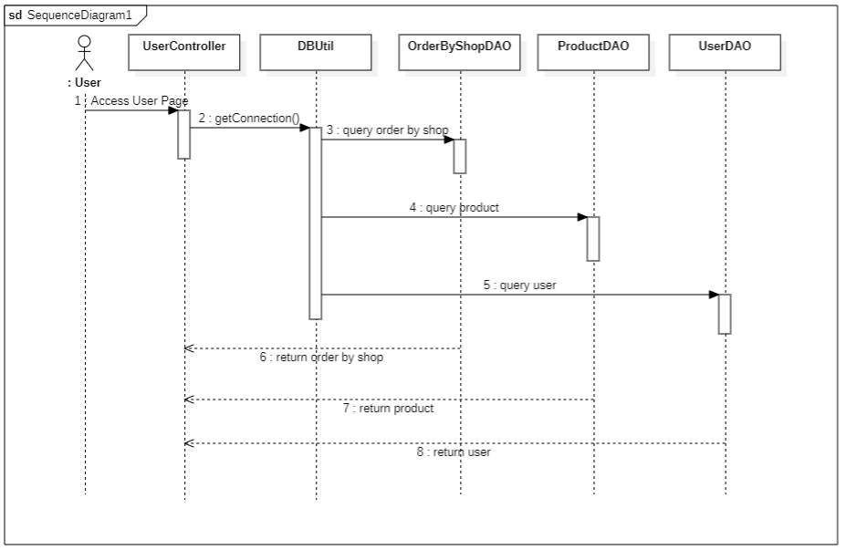

### d. Database queries

### 

UserDAO:

update [user] set [first_name] = ?,

[last_name] = ? ,

[phone] = ? ,

[yob] = ? ,

[address] = ? ,

[ward_id] = ? ,

[district_id] = ? ,

[city_id] = ? ,

where [email] = ?

ProductDAO:

select count(product_id) from product where category_id = ?

select email_seller from product where product_id = ?

select product_id, name from product where name like ? order by name offset 0 rows fetch first ? rows only

select [product_id], [email_seller], [name], [price], [description], [category_id], [quantity], [email_admin], [status], [create_at], [approve_at], [sold_count] from product where category_ID = ?

SELECT product_id, name, price, quantity, sold_count FROM product WHERE email_seller = ? AND status = 1 AND quantity > 0

select [product_id], [email_seller], [name], [price], [description], [category_id], [quantity], [email_admin], [status], [create_at], [approve_at], [sold_count] from product where category_ID = ?

OrderByShopDAO:

INSERT INTO [order_by_shop] (order_id, email_seller) VALUES (?, ?)

SELECT order_by_shop_id FROM order_by_shop WHERE order_id = ? AND email_seller = ?

## 18. <BILL DETAIL>

### a. Class Diagram

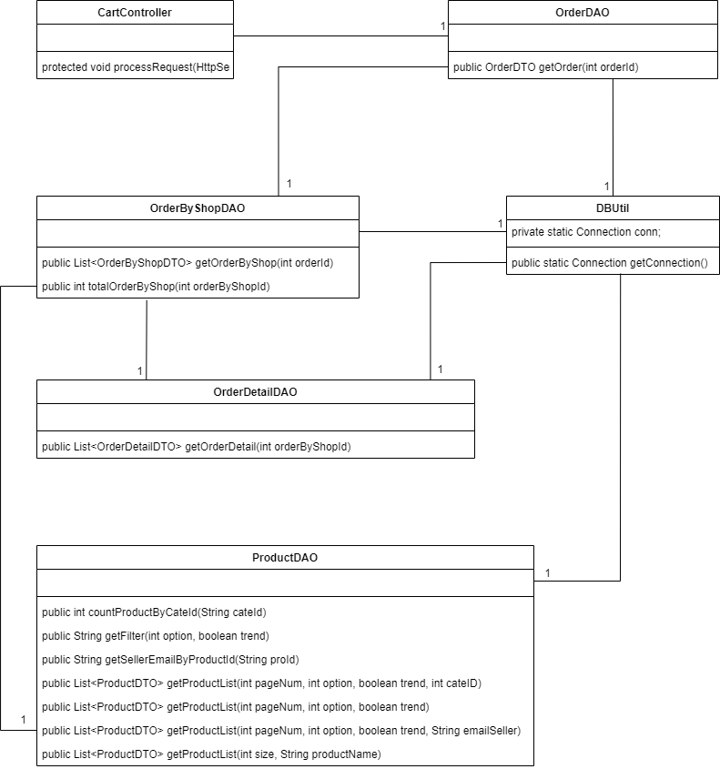

### b. Class Specifications

#### 

#### OrderDAO

| **No** | **Method** | **Description** |
| --- | --- | --- |
| *01* | *public OrderDTO getOrder(int orderId)* | *get order information* |

#### 

#### OrderByShopDAO

| **No** | **Method** | **Description** |
| --- | --- | --- |
| *01* | *public List<OrderByShopDTO> getOrderByShop(int orderId)* | *get details of order list by shop* |
| *02* | *public int totalOrderByShop(int orderByShopId)* | *calculate the price of the order by shop* |

#### 

#### OrderDetailDAO

| **No** | **Method** | **Description** |
| --- | --- | --- |
| *01* | *public List<OrderDetailDTO> getOrderDetail(int orderByShopId)* | *get order list details* |

#### 

#### ProductDAO Class

| **No** | **Method** | **Description** |
| --- | --- | --- |
| *01* | *public int countProductByCateId(String cateId)* | *return total product where cateId = param* |
| *02* | *public String getFilter(int option, boolean trend)* | *return "order by” sql statement* |
| *03* | *public String getSellerEmailByProductId(String proId)* | *return a email of seller that sell a product which have a id passed in* |
| *04* | *public List<ProductDTO> getProductList(int pageNum, int option, boolean trend, int cateID)* | *return a product list base on page number, sort by option (Use the static int final variable in this class),*  *data trend (desc, asc) where category id = parameter passed in* |
| *05* | *public List<ProductDTO> getProductList(int pageNum, int option, boolean trend)* | *return a product list base on page number, sort by option (Use the static int final variable in this class),*  *data trend (desc, asc)* |
| *06* | *public List<ProductDTO> getProductList(int pageNum, int option, boolean trend, String emailSeller)* | *return a product list base on page number, sort by option (Use the static int final variable in this class),*  *data trend (desc, asc) where email of seller = parameter passed in* |
| *07* | *public List<ProductDTO> getProductList(int size, String productName)* | *get array of product base on product name and size of the array passed in* |

#### 

### c. Sequence Diagram(s)

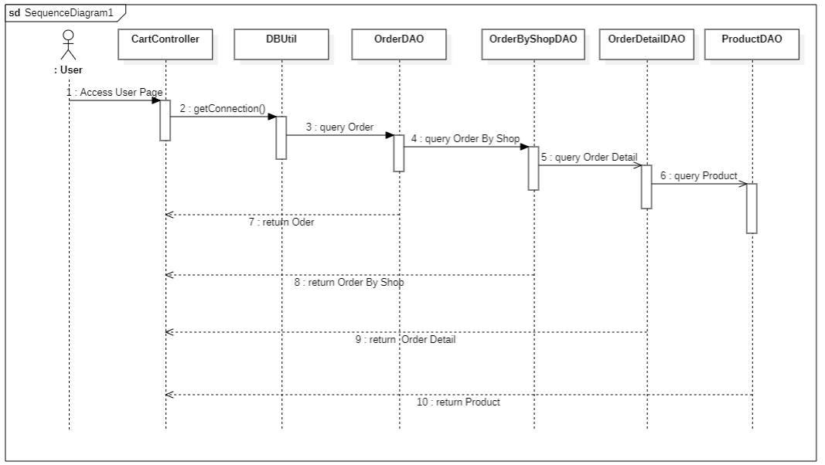

### d. Database queries

UserDAO:

SELECT [order_id], delivery_id, payment_id, email_buyer, order_date, status, address, ward_id, district_id, city_id FROM [order] WHERE email_buyer = ? AND [status] = ?

OrderByShopDAO:

INSERT INTO [order_by_shop] (order_id, email_seller) VALUES (?, ?)

SELECT order_by_shop_id FROM order_by_shop WHERE order_id = ? AND email_seller = ?

OrderDetailDAO:

SELECT quantity FROM [order_detail] WHERE order_by_shop_id = ? AND product_id = ?

INSERT INTO [order_detail] (order_by_shop_id, product_id) VALUES (?, ?)

UPDATE order_detail SET quantity = ? , price = ? WHERE order_by_shop_id = ? AND product_id = ?

ProductDAO:

select count(product_id) from product where category_id = ?

select email_seller from product where product_id = ?

select product_id, name from product where name like ? order by name offset 0 rows fetch first ? rows only

select [product_id], [email_seller], [name], [price], [description], [category_id], [quantity], [email_admin], [status], [create_at], [approve_at], [sold_count] from product where category_ID = ?

SELECT product_id, name, price, quantity, sold_count FROM product WHERE email_seller = ? AND status = 1 AND quantity > 0

select [product_id], [email_seller], [name], [price], [description], [category_id], [quantity], [email_admin], [status], [create_at], [approve_at], [sold_count] from product where category_ID = ?

## 

## 19. <SELLER PAGE>

### a. Class Diagram

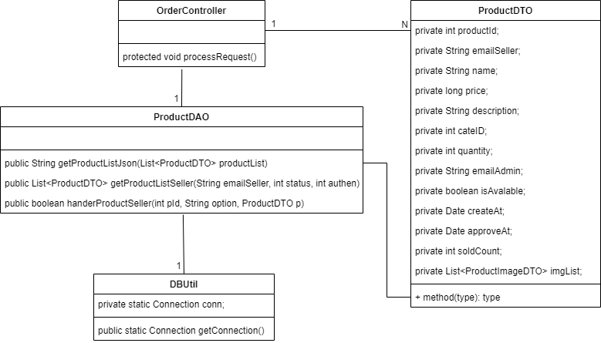

### b. Class Specifications

#### 

#### ProductDAO Class

| **No** | **Method** | **Description** |
| --- | --- | --- |
| *01* | *public String getProductListJson(List<ProductDTO> productList)* | *convert list to json for datatable* |
| *02* | *public List<ProductDTO> getProductListSeller(String emailSeller, int status, int authen)* | *get the product listings that the seller requested* |
| *03* | *public boolean handerProductSeller(int pId, String option, ProductDTO p)* | *handling seller requests* |

#### 

### c. Sequence Diagram(s)

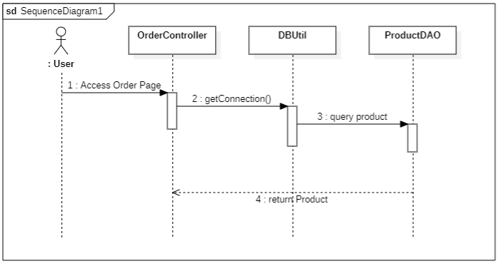

### d. Database queries

UserDAO:

SELECT [order_id], delivery_id, payment_id, email_buyer, order_date, status, address, ward_id, district_id, city_id FROM [order] WHERE email_buyer = ? AND [status] = ?

OrderByShopDAO:

INSERT INTO [order_by_shop] (order_id, email_seller) VALUES (?, ?)

SELECT order_by_shop_id FROM order_by_shop WHERE order_id = ? AND email_seller = ?

OrderDetailDAO:

SELECT quantity FROM [order_detail] WHERE order_by_shop_id = ? AND product_id = ?

INSERT INTO [order_detail] (order_by_shop_id, product_id) VALUES (?, ?)

UPDATE order_detail SET quantity = ? , price = ? WHERE order_by_shop_id = ? AND product_id = ?

ProductDAO:

select count(product_id) from product where category_id = ?

select email_seller from product where product_id = ?

select product_id, name from product where name like ? order by name offset 0 rows fetch first ? rows only

select [product_id], [email_seller], [name], [price], [description], [category_id], [quantity], [email_admin], [status], [create_at], [approve_at], [sold_count] from product where category_ID = ?

SELECT product_id, name, price, quantity, sold_count FROM product WHERE email_seller = ? AND status = 1 AND quantity > 0

select [product_id], [email_seller], [name], [price], [description], [category_id], [quantity], [email_admin], [status], [create_at], [approve_at], [sold_count] from product where category_ID = ?

## 

## 20. <PURCHASE HISTORY>

### a. Class Diagram

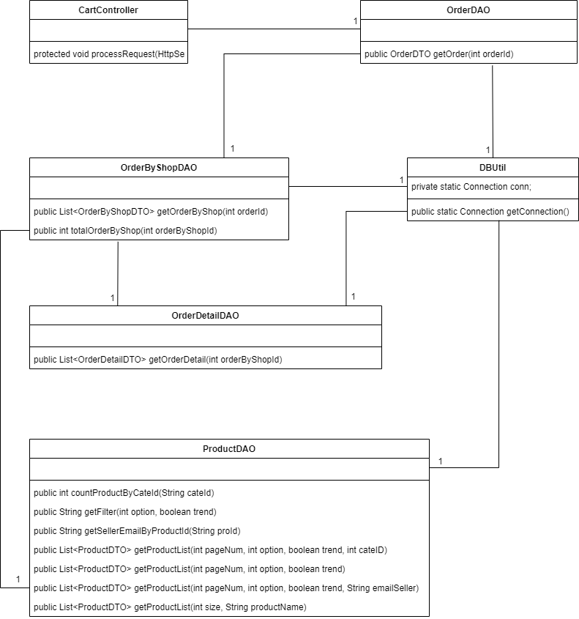

### 

### b. Class Specifications

#### 

#### OrderDAO

| **No** | **Method** | **Description** |
| --- | --- | --- |
| *01* | *public OrderDTO getOrder(int orderId)* | *return a order base on order id* |

#### 

#### OrderByShopDAO

| **No** | **Method** | **Description** |
| --- | --- | --- |
| *01* | *public List<OrderByShopDTO> getOrderByShop(int orderId)* | *return a list of order by shop base on order id* |
| *02* | *public int totalOrderByShop(int orderByShopId)* | *count order by shop base on order id* |

#### 

#### OrderDetailDAO

| **No** | **Method** | **Description** |
| --- | --- | --- |
| *01* | *public List<OrderDetailDTO> getOrderDetail(int orderByShopId)* | *get order details* |

#### 

#### ProductDAO Class

| **No** | **Method** | **Description** |
| --- | --- | --- |
| *01* | *public int countProductByCateId(String cateId)* | *return total product where cateId = param* |
| *02* | *public String getFilter(int option, boolean trend)* | *return "order by” sql statement* |
| *03* | *public String getSellerEmailByProductId(String proId)* | *return a email of seller that sell a product which have a id passed in* |
| *04* | *public List<ProductDTO> getProductList(int pageNum, int option, boolean trend, int cateID)* | *return a product list base on page number, sort by option (Use the static int final variable in this class),*  *data trend (desc, asc) where category id = parameter passed in* |
| *05* | *public List<ProductDTO> getProductList(int pageNum, int option, boolean trend)* | *return a product list base on page number, sort by option (Use the static int final variable in this class),*  *data trend (desc, asc)* |
| *06* | *public List<ProductDTO> getProductList(int pageNum, int option, boolean trend, String emailSeller)* | *return a product list base on page number, sort by option (Use the static int final variable in this class),*  *data trend (desc, asc) where email of seller = parameter passed in* |
| *07* | *public List<ProductDTO> getProductList(int size, String productName)* | *get array of product base on product name and size of the array passed in* |

#### 

### c. Sequence Diagram(s)

**

### d. Database queries

UserDAO:

SELECT [order_id], delivery_id, payment_id, email_buyer, order_date, status, address, ward_id, district_id, city_id FROM [order] WHERE email_buyer = ? AND [status] = ?

OrderByShopDAO:

INSERT INTO [order_by_shop] (order_id, email_seller) VALUES (?, ?)

SELECT order_by_shop_id FROM order_by_shop WHERE order_id = ? AND email_seller = ?

OrderDetailDAO:

SELECT quantity FROM [order_detail] WHERE order_by_shop_id = ? AND product_id = ?

INSERT INTO [order_detail] (order_by_shop_id, product_id) VALUES (?, ?)

UPDATE order_detail SET quantity = ? , price = ? WHERE order_by_shop_id = ? AND product_id = ?

ProductDAO:

select count(product_id) from product where category_id = ?

select email_seller from product where product_id = ?

select product_id, name from product where name like ? order by name offset 0 rows fetch first ? rows only

select [product_id], [email_seller], [name], [price], [description], [category_id], [quantity], [email_admin], [status], [create_at], [approve_at], [sold_count] from product where category_ID = ?

SELECT product_id, name, price, quantity, sold_count FROM product WHERE email_seller = ? AND status = 1 AND quantity > 0

select [product_id], [email_seller], [name], [price], [description], [category_id], [quantity], [email_admin], [status], [create_at], [approve_at], [sold_count] from product where category_ID = ?

## 

## 21. <PAYMENT>

### a. Class Diagram

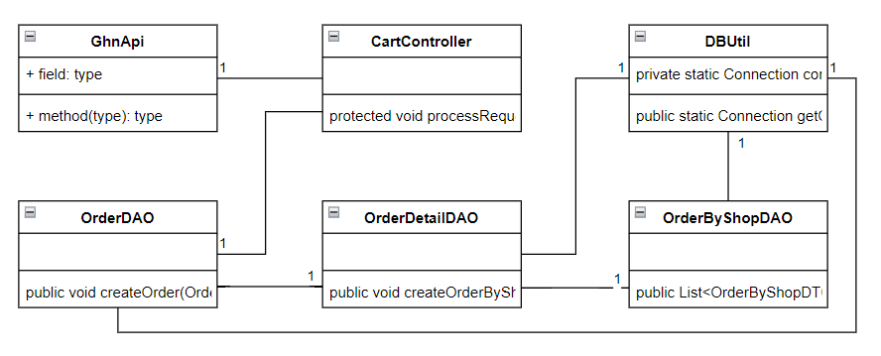

### b. Class Specifications

#### GhnApi

| **No** | **Method** | **Description** |
| --- | --- | --- |
| *01* | *public static String createOrder(UserDTO user, UserDTO seller, List<OrderDetailDTO> orderDetails, String cod)* | *create a giao hang nhanh order using REST api* |

#### OrderDAO

| **No** | **Method** | **Description** |
| --- | --- | --- |
| *01* | *public void createOrder(OrderDTO order)* | *insert data into database in table order* |

#### 

#### OrderByShopDAO

| **No** | **Method** | **Description** |
| --- | --- | --- |
| *01* | *public List<OrderByShopDTO> getOrderByShop(int orderId)* | *insert data into database in table order_by_shop* |

#### 

#### OrderDetailDAO

| **No** | **Method** | **Description** |
| --- | --- | --- |
| *01* | *public void createOrderByShop(int orderId, OrderByShopDTO obs)* | *insert data into database in table order_detail* |

#### 

#### ProductDAO Class

| **No** | **Method** | **Description** |
| --- | --- | --- |
| *01* | *public int countProductByCateId(String cateId)* | *return total product where cateId = param* |
| *02* | *public String getFilter(int option, boolean trend)* | *return "order by” sql statement* |
| *03* | *public String getSellerEmailByProductId(String proId)* | *return a email of seller that sell a product which have a id passed in* |
| *04* | *public List<ProductDTO> getProductList(int pageNum, int option, boolean trend, int cateID)* | *return a product list base on page number, sort by option (Use the static int final variable in this class),*  *data trend (desc, asc) where category id = parameter passed in* |
| *05* | *public List<ProductDTO> getProductList(int pageNum, int option, boolean trend)* | *return a product list base on page number, sort by option (Use the static int final variable in this class),*  *data trend (desc, asc)* |
| *06* | *public List<ProductDTO> getProductList(int pageNum, int option, boolean trend, String emailSeller)* | *return a product list base on page number, sort by option (Use the static int final variable in this class),*  *data trend (desc, asc) where email of seller = parameter passed in* |
| *07* | *public List<ProductDTO> getProductList(int size, String productName)* | *get array of product base on product name and size of the array passed in* |

#### 

### c. Sequence Diagram(s)

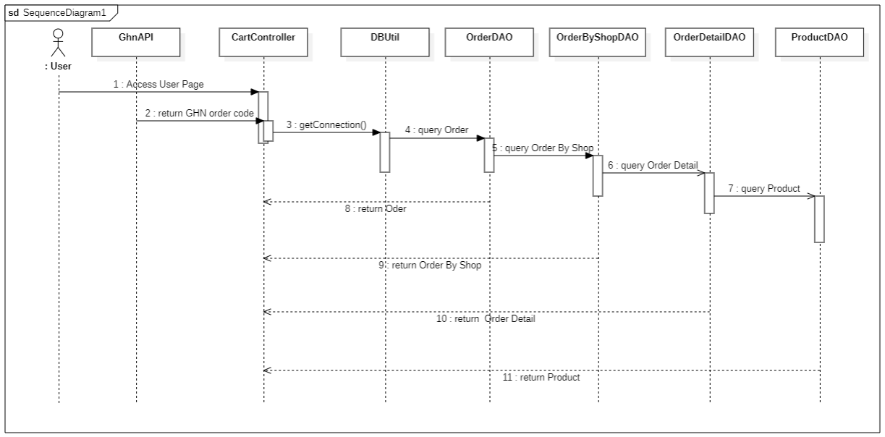

### d. Database queries

UserDAO:

SELECT [order_id], delivery_id, payment_id, email_buyer, order_date, status, address, ward_id, district_id, city_id FROM [order] WHERE email_buyer = ? AND [status] = ?

OrderByShopDAO:

INSERT INTO [order_by_shop] (order_id, email_seller) VALUES (?, ?)

SELECT order_by_shop_id FROM order_by_shop WHERE order_id = ? AND email_seller = ?

OrderDetailDAO:

SELECT quantity FROM [order_detail] WHERE order_by_shop_id = ? AND product_id = ?

INSERT INTO [order_detail] (order_by_shop_id, product_id) VALUES (?, ?)

UPDATE order_detail SET quantity = ? , price = ? WHERE order_by_shop_id = ? AND product_id = ?

ProductDAO:

select count(product_id) from product where category_id = ?

select email_seller from product where product_id = ?

select product_id, name from product where name like ? order by name offset 0 rows fetch first ? rows only

select [product_id], [email_seller], [name], [price], [description], [category_id], [quantity], [email_admin], [status], [create_at], [approve_at], [sold_count] from product where category_ID = ?

SELECT product_id, name, price, quantity, sold_count FROM product WHERE email_seller = ? AND status = 1 AND quantity > 0

select [product_id], [email_seller], [name], [price], [description], [category_id], [quantity], [email_admin], [status], [create_at], [approve_at], [sold_count] from product where category_ID = ?

## 22. <[R](https://docs.google.com/document/d/1e0yA5Z7L8BlFa-ovUPd5vcr6bQ8bFkrO/edit#heading=h.hk9b0i40nsjz)EVIEW>

### a. Class Diagram

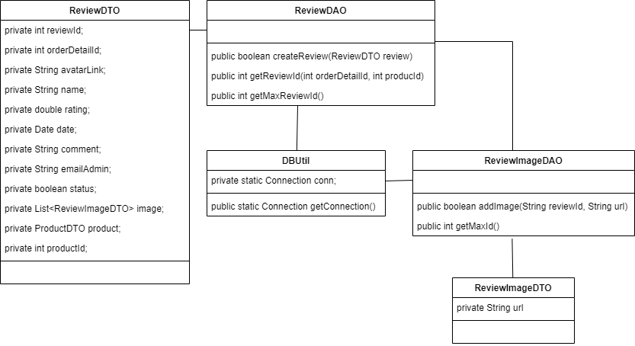

### b. Class Specifications

#### 

#### ReviewDAO

| **No** | **Method** | **Description** |
| --- | --- | --- |
| *01* | *public boolean createReview(ReviewDTO review)* | *create review to database* |
| *02* | *public int getReviewId(int orderDetailId, int producId)* | *get review id from order detail id and product id* |
| *03* | *public int getMaxReviewId()* | *get maximum of review id* |

#### 

#### ReviewImageDAO

| **No** | **Method** | **Description** |
| --- | --- | --- |
| *01* | *public boolean addImage(String reviewId, String url)* | *add review image to database* |
| *02* | *public int getMaxId()* | *get maximum of review image id* |

#### 

### c. Sequence Diagram(s)

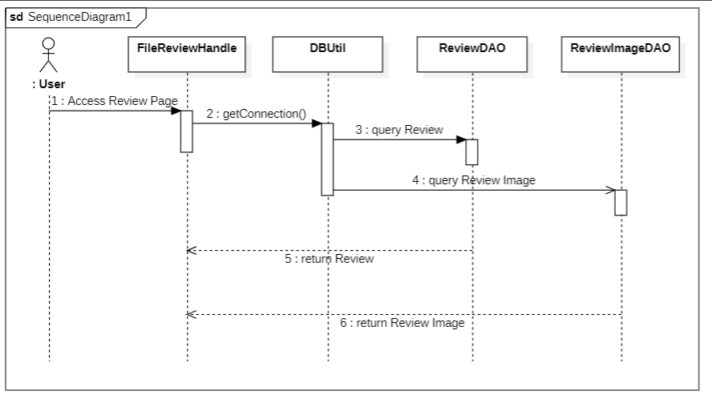

### d. Database queries

INSERT INTO [dbo].[image_review] ([review_id] , [url]), values (?, ?)

select max([image_id]) from [image_review]

select review_id from review r

inner join order_detail od on r.order_detail_id = od.order_detail_id

where r.order_detail_id = ? and od.product_id = ?

select max(review_id) from review

INSERT INTO [dbo].[review] ([order_detail_id] , [rating], [comment], [email_admin], [status], [date]) values (?, ?, ?, ?, ?, ?)

# 

# III. Database Tables

## 1. < city >

| **#** | **Field name** | **Type** | **Size** | **Unique** | **Not Null** | **PK/FK** | **Notes** |
| --- | --- | --- | --- | --- | --- | --- | --- |
| 1 | city_id | NVARCHAR | 20 | x | x | PRIMARY KEY |  |
| 2 | name | NVARCHAR | 255 |  | x |  |  |

## 2. < district >

| **#** | **Field name** | **Type** | **Size** | **Unique** | **Not Null** | **PK/FK** | **Notes** |
| --- | --- | --- | --- | --- | --- | --- | --- |
| 1 | district_id | NVARCHAR | 20 | x | x | PRIMARY KEY |  |
| 2 | name | NVARCHAR | 255 |  | x |  |  |
| 3 | city_id | NVARCHAR | 20 |  |  | FOREIGN KEY | FK_DISTRICT_RE_CITY |

## 3. < Ward >

| **#** | **Field name** | **Type** | **Size** | **Unique** | **Not Null** | **PK/FK** | **Notes** |
| --- | --- | --- | --- | --- | --- | --- | --- |
| 1 | ward_id | NVARCHAR | 20 | x | x | PRIMARY KEY |  |
| 2 | name | NVARCHAR | 255 |  | x |  |  |
| 3 | district_id | NVARCHAR | 20 |  |  | FOREIGN KEY | FK_WARD_RE_DISTRICT |

## 4. < Role >

| **#** | **Field name** | **Type** | **Size** | **Unique** | **Not Null** | **PK/FK** | **Notes** |
| --- | --- | --- | --- | --- | --- | --- | --- |
| 1 | role_id | INT |  | x | x | PRIMARY KEY | IDENTITY (0,1) |
| 2 | name | NVARCHAR | 10 | x | x |  |  |

## 

## 5. < user >

| **#** | **Field name** | **Type** | **Size** | **Unique** | **Not Null** | **PK/FK** | **Notes** |
| --- | --- | --- | --- | --- | --- | --- | --- |
| 1 | email | VARCHAR | 50 | x | x | PRIMARY KEY |  |
| 2 | avatar | TEXT |  |  | x |  |  |
| 3 | first_name | NVARCHAR | 40 |  |  |  |  |
| 4 | last_name | NVARCHAR | 40 |  |  |  |  |
| 5 | phone | VARCHAR | 10 | x |  |  |  |
| 6 | yob | DATE |  |  |  |  |  |
| 7 | address | NTEXT |  |  |  |  |  |
| 8 | ward_id | NVARCHAR | 20 |  |  | FOREIGN KEY | FK_USER_RE_WARD |
| 19 | district_id | NVARCHAR | 20 |  |  | FOREIGN KEY | FK_USER_RE_DISTRICT |
| 10 | city_id | NVARCHAR | 20 |  |  | FOREIGN KEY | FK_USER_RE_CITY |
| 11 | role_id | INT |  |  |  | FOREIGN KEY | FK_USER_RE_ROLE |

## 6. < category >

| **#** | **Field name** | **Type** | **Size** | **Unique** | **Not Null** | **PK/FK** | **Notes** |
| --- | --- | --- | --- | --- | --- | --- | --- |
| 1 | category_id | INT |  | x | x | PRIMARY KEY | IDENTITY (0,1) |
| 2 | name | NVARCHAR | 40 | x | x |  |  |
| 3 | icon | VARCHAR | 100 |  |  |  |  |

## 7. < delivery_method >

| **#** | **Field name** | **Type** | **Size** | **Unique** | **Not Null** | **PK/FK** | **Notes** |
| --- | --- | --- | --- | --- | --- | --- | --- |
| 1 | delivery _id | INT |  | x | x | PRIMARY KEY | IDENTITY (0,1) |
| 2 | name | NVARCHAR | 40 | x | x |  |  |

## 8. < payment_method >

| **#** | **Field name** | **Type** | **Size** | **Unique** | **Not Null** | **PK/FK** | **Notes** |
| --- | --- | --- | --- | --- | --- | --- | --- |
| 1 | payment _id | INT |  | x | x | PRIMARY KEY | IDENTITY (0,1) |
| 2 | name | NVARCHAR | 40 | x | x |  |  |

## 9. < product >

| **#** | **Field name** | **Type** | **Size** | **Unique** | **Not Null** | **PK/FK** | **Notes** |
| --- | --- | --- | --- | --- | --- | --- | --- |
| 1 | product_id | INT |  | x | x | PRIMARY KEY | IDENTITY (0,1) |
| 2 | email (seller) | VARCHAR | 50 |  | x | FOREIGN KEY | FK_PRODUCT_RE_SELLER |
| 3 | name | NVARCHAR | 100 |  | x |  |  |
| 4 | price | NUMERIC | (12.0) |  | x |  | CHECK price >= 0 |
| 5 | description | NTEXT |  |  |  |  |  |
| 6 | category_id | INT |  |  | x | FOREIGN KEY | FK_PRODUCT_RE_CATEGORY |
| 7 | quantity | INT |  |  | x |  | DEFAULT (0)  CHECK quantity >= 0 |
| 8 | email_admin | VARCHAR | 50 |  |  | FOREIGN KEY | FK_PRODUCT_RE_ADMIN |
| 9 | sold_count | INT |  |  | x |  | DEFAULT (0) |
| 10 | status | BIT |  |  | x |  | DEFAULT (0) |
| 11 | create_at | DATE |  |  | x |  |  |
| 12 | approve_at | DATE |  |  |  |  |  |

## 10. < image_product >

| **#** | **Field name** | **Type** | **Size** | **Unique** | **Not Null** | **PK/FK** | **Notes** |
| --- | --- | --- | --- | --- | --- | --- | --- |
| 1 | image _id | INT |  | x | x | PRIMARY KEY | IDENTITY (0,1) |
| 2 | product_id | INT |  |  | x | FOREIGN KEY | FK_IMAGE_PRODUCT_RE_PRODUCT |
| 3 | url | TEXT |  |  |  |  |  |
| 4 | Is_main_img | BIT |  |  | x |  | DEFAULT (0) |

## 11. < order >

| **#** | **Field name** | **Type** | **Size** | **Unique** | **Not Null** | **PK/FK** | **Notes** |
| --- | --- | --- | --- | --- | --- | --- | --- |
| 1 | order_id | INT |  | x | x | PRIMARY KEY | IDENTITY (0,1) |
| 2 | delivery_id | INT |  |  |  | FOREIGN KEY | FK_ORDER_RE_DELIVERY |
| 3 | payment_id | INT |  |  |  | FOREIGN KEY | FK_ORDER_RE_PAYMENT |
| 4 | email (buyer) | VARCHAR | 50 |  | x | FOREIGN KEY | FK_ORDER_RE_BUYER |
| 5 | order_date | DATE |  |  |  |  |  |
| 6 | shipper_date | DATE |  |  |  |  |  |
| 7 | address | NTEXT |  |  |  |  |  |
| 8 | ward_id | NVARCHAR | 20 |  |  | FOREIGN KEY | FK_ORDER_RE_WARD |
| 9 | district_id | NVARCHAR | 20 |  |  | FOREIGN KEY | FK_ORDER_RE_DISTRICT |
| 10 | city_id | NVARCHAR | 20 |  |  | FOREIGN KEY | FK_ORDER_RE_CITY |

## 12. < order_detail>

| **#** | **Field name** | **Type** | **Size** | **Unique** | **Not Null** | **PK/FK** | **Notes** |
| --- | --- | --- | --- | --- | --- | --- | --- |
| 1 | order_details_id | INT |  | x | x | PRIMARY KEY | IDENTITY (0,1) |
| 2 | order_by_shop_id | INT |  |  | x | FOREIGN KEY | FK_ORDER_DETAIL_RE_ORDER |
| 3 | product_id | INT |  |  | x | FOREIGN KEY | FK_ORDER_DETAIL_RE_PRODUCT |
| 4 | quantity | INT |  |  | x |  | CHECK quantity >= 0 |
| 5 | price | NUMERIC | (12,0) |  |  |  | CHECK price >= 0 |

## 13. < order_by_shop>

| **#** | **Field name** | **Type** | **Size** | **Unique** | **Not Null** | **PK/FK** | **Notes** |
| --- | --- | --- | --- | --- | --- | --- | --- |
| 1 | order_by_shop_id | INT |  | x | x | PRIMARY KEY | INDENTITY (0,1) |
| 2 | order _id | INT |  |  | x | FOREIGN KEY | FK_FEP_ORDER_BY_SHOP_RE_FEP_ORDER |
| 3 | email (seller) | VARCHAR | 50 |  | x | FOREIGN KEY | FK_FEP_ORDER_BY_SHOP_RE_USER |
| 4 | transaction_fee | NUMERIC (12,0) |  |  | x |  |  |
| 5 | transport_fee | NUMERIC (12,0) |  |  |  |  |  |
| 6 | shipped_date | DATE |  |  |  |  |  |

## 14. < review >

| **#** | **Field name** | **Type** | **Size** | **Unique** | **Not Null** | **PK/FK** | **Notes** |
| --- | --- | --- | --- | --- | --- | --- | --- |
| 1 | review _id | INT |  | x | x | PRIMARY KEY | IDENTITY (0,1) |
| 2 | order_detail_id | INT |  |  | x | FOREIGN KEY | FK_REVIEW_RE_ODER_DETAIL |
| 3 | rating | FLOAT |  |  | x |  |  |
| 4 | comment | NTEXT |  |  |  |  |  |
| 5 | email (admin) | VARCHAR | 50 |  |  | FOREIGN KEY | FK_REVIEW_RE_ADMIN |
| 6 | status | BIT |  |  | x |  | DEFAULT (0) |

## 15. < image_review >

| **#** | **Field name** | **Type** | **Size** | **Unique** | **Not Null** | **PK/FK** | **Notes** |
| --- | --- | --- | --- | --- | --- | --- | --- |
| 1 | image _id | INT |  | x | x | PRIMARY KEY | IDENTITY (0,1) |
| 2 | review_id | INT |  |  | x | FOREIGN KEY | FK_IMAGE_REVIEW_RE_REVIEW |
| 3 | url | TEXT |  |  | x |  |  |

## 16. < banner >

| **#** | **Field name** | **Type** | **Size** | **Unique** | **Not Null** | **PK/FK** | **Notes** |
| --- | --- | --- | --- | --- | --- | --- | --- |
| 1 | banner_id | INT |  | x | x | PRIMARY KEY | IDENTITY (0,1) |
| 2 | name | VARCHAR | 100 |  | x |  |  |
| 3 | type_banner | BIT |  |  | x |  | DEFAULT (0) |